# CHAPTER ONE

## INTRODUCTION

## Background of Study

Renewable energy is a critical component of the 17 Sustainable Development Goals (SDGs) aimed at promoting sustainable development. The goal is to ensure easy access to and improvement in energy efficiency for all by (United Nations, 2015). Unlike conventional energy sources associated with fossil fuels, renewable energy sources have little or no harmful effects on human life and biodiversity. Fossil fuels, on the other hand, emit greenhouse gases, which contribute to global warming and pose a long-term cost to maintain power supply stability, reported that CO2 emissions from electricity and heat generation account for 42% of other greenhouse gases worldwide. Furthermore, due to the ever-growing population, increase in deforestation, and technological advancements now is the time to invest and harness the power embedded in renewable energy (Olujobi & Olusola-Olujobi, 2020). (Vidyanandan, 2018) reported that CO2 emissions from electricity and heat generation account for 42% of other greenhouse gases worldwide.

The use of fossil fuels as the primary energy source for mobile communication base stations (cell sites) in Nigeria has resulted in high maintenance costs, and the rate of fuel theft by personnel in charge of monitoring cell sites is also significant. This situation has a negative impact on human health and the environment (Owusu & Asumadu-Sarkodie, 2016). Regarding the distribution of the World’s Renewable Energy consumption by (Statista, 2023), Wind Energy was predicted to be the third most used renewable energy in the world in 2023 as shown in Figure 1.1, which underlines its potential and how important it is in today’s current energy consumption.

**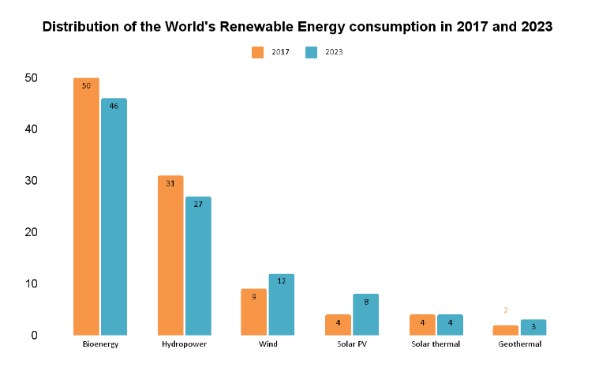****Figure 1.1**: Distribution of renewable energy consumption worldwide in 2017 and 2023, by technology

Although Solar energy which is widely used in Nigeria is the only established renewable energy but based on the estimate of Renewable energy in Nigeria as shown in Figure 1.2, it is evident that Wind Energy has the potential of 1600MW and 800MW for onshore and offshore wind respectively which will boost the nation’s energy demand in combination with the remaining Renewable energies since the country is blessed with the right environmental and atmospheric factors for it to thrive well (Olaoye et al., 2016).

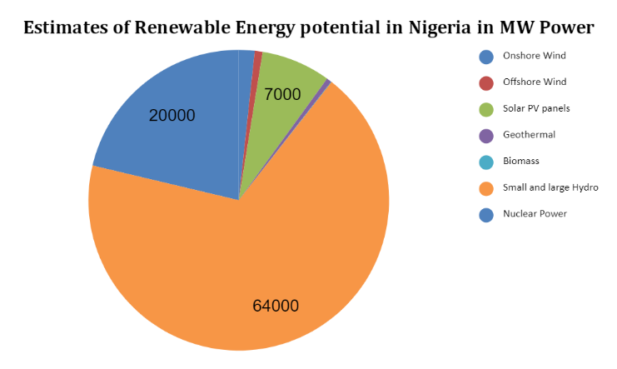

**Figure 1.2**: Estimates of Renewable Energy Potential in Nigeria (MW)

According to (Buturache & Stancu, 2021), researchers have developed methods to predict when wind energy will be in abundance and can be stored for use. These methods include physical, statistical, and artificial intelligence (AI) approaches, particularly machine learning, which can accurately forecast wind energy availability on an hourly, daily, monthly, or seasonal basis.

The objective of this study is to utilize machine learning (ML) to forecast wind energy as an alternative power source for telecommunications-based stations located in Nigeria. The literature review focused on the analysis of several locations in Nigeria as a case study, along with references to other countries to highlight the importance of conducting this research. Numerous reviewed case studies have been conducted in Nigeria to predict wind energy using the statistical 2-parameter Weibull distribution model, with more than 20 studies demonstrating its accuracy. On the other hand (Fadare, 2010), used an artificial neural network (ANN) to predict wind energy based on twenty years of data sets (1983-2003), which may no longer be valid for 2022 predictions. The dataset is now seen as obsolete and using such predictions in 2022 based on this data may not provide the required and accurate predictions needed. Furthermore, the study's wind speed prediction error metric of MAPE was 8.9%, indicating room for improvement

The need for accurate wind speed prediction has led to the development of various models for forecasting wind energy, with a focus on improving prediction accuracy. To this end, researchers have advocated for the use of up-to-date datasets and improved prediction techniques, such as the LSTM model. In line with this, the present research is focused on the collection and pre-processing of wind speed data from Kano, Nigeria, and the development of an LSTM model for predicting future wind speed based on ten years of wind speed data (2008-2017). The data is sourced from a region with high wind speeds, as research has shown that wind speeds in the north range from 4.0 to 7.5 metres per second, making it an ideal location for wind energy generation (Adedipe et al., 2018). The developed LSTM model will be evaluated with error metrics to ensure its prediction accuracy.

Although these statistics affirm that the northern region of Nigeria has an abundance of wind, which is a criterion for wind energy generation, the same cannot be said for the southern part of the country. Therefore, the wind speed dataset collected from Kano, a city in northern Nigeria, is pre-processed to remove outliers and ensure that the data is suitable for accurate prediction. This pre-processed data is then evaluated using known prediction tools such as Root Mean Squared Error (RMSE), Mean Squared Error (MSE), Mean Absolute Error (MAE), and Mean Absolute Percentage Error (MAPE), using the Python programming language and its libraries (da Silva et al., 2022).

Lastly, a hybrid energy that comprises both wind and solar renewable energy is proposed based on the result gotten, which can serve as the primary energy source for cell sites, while fossil fuels can be used as a backup energy source. Several studies have highlighted the potential benefits of using hybrid energy systems for powering cell sites. For instance, a study by (Oladigbolu et al., 2020) examined the feasibility of using a hybrid energy system to power cell sites in Nigeria and found that it could lead to significant cost savings and environmental benefits. Another study by (Olatomiwa et al., 2015)) evaluated the performance of a hybrid energy system comprising solar, wind, and battery storage for powering cell sites in Nigeria and found that it could provide reliable and cost-effective power. These studies underscore the potential of hybrid energy systems as a viable solution for powering cell sites in Nigeria and other parts of the world.

## 1.2 Motivation for Study

Nigeria has significant untapped potential for wind energy compared to solar renewable energy, yet it has not been fully utilized. (Adedipe et al., 2018) argue that Nigeria should follow other countries in adopting renewable energy sources, especially wind energy, to achieve sustainable development goal 7. The International Energy Agency (IEA) reports that Nigeria has the potential to generate over 4,000 MW of electricity through wind energy but currently produces only 13 MW (Oyedepo et al., 2019). To reduce the country's dependence on fossil fuels and provide reliable and affordable electricity to all Nigerians, particularly in rural areas, it is crucial for Nigeria to invest in wind energy sources (Oyedepo et al., 2019). To reduce the country's dependence on fossil fuels and provide reliable and affordable electricity to all Nigerians, particularly in rural areas, it is crucial for Nigeria to invest in wind energy sources (Olujobi & Olusola-Olujobi, 2020).

Nigeria's Katsina state wind farm, which generates ten megawatts (10MW), remains the only operational wind farm in Nigeria (Alain Charles, 2015). However, the Nigerian government has taken significant steps to achieve universal energy access by 2030 and contribute to net-zero emissions by 2060, including launching the Nigeria Integrated Energy Planning Tool in collaboration with Sustainable Energy for All (SEforALL). The tool aims to promote energy efficiency and renewable energy development, with a focus on wind energy, to provide affordable, reliable, and sustainable electricity to Nigerians. Investing in wind energy will also create job opportunities, enhance workforce development, improve energy security, and reduce the financial burden associated with importing fossil fuels ((SEforALL, 2022); (Olujobi & Olusola-Olujobi, 2020)).

The use of renewable energy sources is gaining momentum in Nigeria, and accurately predicting the output of these sources is essential for effective integration into the power grid. Several studies in Nigeria have used the 2-parameter Weibull distribution function model, a statistical method of prediction, which has shown great performance. This method has been identified as the most effective statistical means for predicting small data sets. However, for large data sets, the effectiveness of the Weibull model is reduced, and machine learning (ML) has been proposed as a better alternative due to its robustness and prediction accuracy (FRANCAS, 2019).

According to a study by (Fadare, 2010), predictions of wind speed in Nigeria using an Artificial Neural Network (ANN) yielded an accuracy of 8.9% (MAPE) and 0.9380 (correlation coefficient (R)). However, since that study, there have been significant technological advancements, and factors such as changes in abiotic factors and deforestation have intensified. Therefore, it is crucial to develop new, advanced Machine Learning (ML) models with high prediction accuracy to make reliable wind speed predictions for energy solutions. In line with this, this study aims to predict wind speed using ML on a new dataset (2008-2017) to provide energy solutions for telecommunication base stations in Nigeria. This research seeks to fully harness wind energy when it is abundant based on the most accurate predictions that will be generated from the analysis. The goal is to use both solar and wind energy as the primary sources of energy, with fossil fuel only serving as a backup. The utilization of renewable energy sources such as wind and solar will help to reduce the dependence on fossil fuels and mitigate their harmful effects on the environment (UNEP, 2017).

## 1.3 Aim

This research aims to develop an efficient machine learning-based wind speed prediction model for renewable energy solutions to power telecommunication base-station in Nigeria.

## 1.4 Objectives

The research is aimed at fulfilling the following objectives, namely:

1. Collect wind speed data from Nigerian Meteorological Agency (NIMET)
2. Pre-process the datasets using Feature Engineering and Normalization technique
3. Use the Long Short-Term Memory (LSTM) model for training the processed datasets with the best hyper-parameters and time-steps.
4. Test and evaluate the proposed LSTM model performance by comparing it with other prediction models.
5. Create sustainable energy to power base transceiver stations (BTS) in Nigeria.
6. Create an eco-friendly source of energy thereby reducing the carbon footprints in the atmosphere.
7. Enable a cost-effective source of energy.
8. Ensure a stable hybrid source of energy for telecommunication-based stations.
9. Reduce over-reliance on Conventional Energy systems.

## 1.5 Methodology

This research method was done based on five stages, namely:

1. Data Collection: Ten years (2008-2017) of northern Nigeria wind speed data was collected from NiMet (Nigerian Meteorological Agency).
2. Data Pre-Processing: Using Python programming and its libraries, the data was first checked for missing data and outliers, and then normalization and feature engineering was performed to transform the data into a time-series sequence. Also, these processed data were divided into training and testing datasets with a specified ratio.
3. Model Development: Here, the LSTM model was trained using the training dataset.
4. Model Testing and Evaluation: Firstly, the trained model was tested and predicted using the testing datasets, and then the performance of each hyper-parameter was evaluated based on RMSE, MSE, MAE, R2, and MAPE, by comparing it with other prediction models.

## 1.6 Significance of study/Expected Contribution

This study aims to address the challenge of unreliable power supply in the telecommunication sector by predicting daily wind energy combined with the already accessible Solar energy as a hybrid energy system to power telecommunication base stations (BTSs) in Nigeria. The use of renewable energy sources such as wind and solar energy has been found to be an effective means of mitigating the impact of greenhouse gas emissions and climate change, while also ensuring a sustainable energy supply (Adedipe et al., 2018). By implementing a hybrid energy system for BTSs in Nigeria, the telecommunication sector can reduce its dependence on fossil fuels and significantly decrease its carbon footprint.

In recent years, there has been a global shift towards renewable energy sources, and Nigeria is not left out of this trend. The country has set a target to achieve a 30% renewable energy mix by 2030, as part of its efforts to address energy poverty and reduce its carbon emissions (Olatomiwa et al., 2015). Furthermore, the Nigerian government has launched initiatives aimed at increasing the deployment of renewable energy systems, such as the National Renewable Energy and Energy Efficiency Policy and the National Renewable Energy Action Plan.

The integration of wind and solar energy sources for BTSs in Nigeria can lead to a more reliable and efficient energy supply. Wind energy is abundant in Nigeria, with the country's northern region having a high wind potential due to its location within the West African monsoon system (Olujobi & Olusola-Olujobi, 2020). On the other hand, solar energy is readily available throughout the country, with an average daily insolation of 4.8 kWh/m²/day (Nwokocha et al., 2009). By harnessing the energy from both sources, the hybrid energy system can provide a stable and reliable energy supply for BTSs, especially in areas with poor grid connectivity. Moreover, the proposed hybrid energy system will reduce the telecommunication sector's carbon footprint in Nigeria and provide cost savings in the long run. The installation and maintenance costs of renewable energy systems have significantly reduced in recent years, making them more economically viable than traditional energy sources in many parts of the world (Maradin et al., 2017). By reducing the dependence on fossil fuels, the hybrid energy system can help the telecommunication sector save costs on fuel procurement, transportation, and storage, as well as reduce the risks associated with fuel theft and adulteration.

In summary, the integration of wind and solar energy sources can provide a sustainable and reliable energy supply for telecommunication base stations in Nigeria. The proposed hybrid energy system can reduce the carbon footprint of the sector and provide cost savings in the long run, while also contributing to the country's renewable energy targets.

**CHAPTER TWO**

**LITERATURE REVIEW**

**2.1   Introduction**

         This chapter review works on Mobile communication Systems about their Evolution, Architecture based on MS, BSS, NSS, and OSS. Then the Base station energy system; its costs, environmental impact, and greenhouse gas emissions. The power solutions for Base Transceiver Stations (BTS)**,** which is the power from the electricity grid, Diesel Generators, renewable energy solutions, and technologies. It also addresses the use of renewable energy as an alternative solution, which is a Hybrid power System, and deploring this to power BTS. This hybrid energy is a conversion of energy from wind for real-time usage. Due to the randomness of the wind, its measurement is taken at a specific time interval. These data will be used to forecast and predict what will happen in the future. Time-series forecasting which forms the basis of Wind speed prediction was briefly discussed and the models commonly used for wind speed prediction were highlighted. For the focus of this research work, related works on Wind power prediction using Machine learning (ML) for Nigeria's and Other countries’ datasets were reviewed and cited based on Data collection, Data pre-processing, Machine Learning (ML) development, and Model Evaluation.  Lastly, a summary of the topics treated above was analysed, serving as the focal point of this research work.

**Table 2.1: Keywords**

|  |  |  |  |
| --- | --- | --- | --- |
| ***Abbreviations*** | ***Meaning*** | ***Abbreviations*** | ***Meaning*** |
| ***ARIMA*** | *Autoregressive integrated moving average* | ***ML*** | *Machine Learning* |
| ***BSC*** | *Base Station Controller* | ***mRMR*** | *Minimum redundancy maximum relevance algorithm* |
| ***BTS*** | *Base Transceiver Station* | ***MLP*** | *Multilayer Perceptron* |
| ***BSS*** | *Base Station Subsystem* | ***NN*** | *Neural network* |
| ***COE*** | *coefficient of efficiency* | ***NREL*** | *National Renewable Energy Laboratory* |
| ***DMLPNN-CSO*** | *Deep Multilayer Perceptron Neural Network based Clonal Selective Optimization* | ***NCC*** | *Nigerian Communication Commission* |
| ***DN*** | *Deep network* | ***NARX-NN*** | *Nonlinear autoregressive exogenous inputs neural network* |
| ***DDN*** | *Data-oriented Deep Network* | ***NSS*** | *Network Switching Subsystem* |
| ***FPA*** | *Flower pollination algorithm* | ***nodeB*** | *Radio Base Station in 3G)* |
| ***GRU*** | *Gated recurrent unit network* | ***OSS*** | *Operation Support Subsystem* |
| ***GSM*** | *Global System for Mobile Communications* | ***PR*** | *Polynomial regression* |
| ***HLR*** | *home location register* | ***PSTN*** | *Public Switched Telephone Network* |
| ***IOWA*** | *Improved ensemble Empirical mode decomposition* | ***PR*** | *Polynomial regression* |
| ***ICEEMDAN*** | *Improved ensemble Empirical mode decomposition* | ***RNC*** | *Radio Network Controller* |
| ***IMVO-ELM*** | *Improved multiverse optimizer-extreme learning machine* | ***RF*** | *Radio Frequency* |
| ***KF*** | *Kalman Filter* | ***R2*** | *Correlation Coefficient of Determination* |
| ***LTE*** | *Long-Term Evolution* | ***R*** | *Correlation Coefficient* |
| ***LRP*** | *Learning-based predictor* | ***RMSE*** | *Root Mean Square Error* |
| ***MS*** | *Mobile Station* | ***RBF*** | *Radial basis function* |
| ***MSC*** | *Mobile Switching Centre* | ***SOM*** | *Self-organizing map* |
| ***MSE*** | *Mean square error* | ***SIM*** | *Subscriber identification module* |
| ***MAE*** | *Mean Absolute Error* | ***SVM*** | *Support Vector Machine neural network* |
| ***MAPE*** | *Mean absolute Percentage Error* | ***SH*** | *Selective Hankelization* |
| ***MBE*** | *Mean Bias error* | ***TDMA*** | *Time Division Multiple Access* |
| ***MERRA-1*** | *Modern-Era Retrospective Analysis* | ***χ2*** | *Chi-Square* |

### **2.2   Mobile Communication Systems**

The transfer of information over a distance everywhere with anybody and at any time, this happens to be the dream and goal of researchers, engineers and end-users, since the advent of the communication system. Today it feels like the goal has almost been reached that, Communication networks are becoming more digital, microelectronics, computers, and software technology have advanced dramatically, the invention of efficient algorithms and techniques for compression, security, and processing of all types of signals, as well as the development of flexible communication protocols, have all been key requirements for this achievement. Today's technologies make it possible to build high-performance, cost-effective communication systems for a wide range of applications. The information in this chapter comes from a variety of sources, including field experience, technical detailing, interactions with industry experts, and other sources.

With today's wireless communication technology, it's undeniable that users can roam not just within a network, but also between networks, allowing them to communicate anywhere, with anyone, and at any time. The enormous difference between data speeds available through wireless services, those available through wired services, and, most importantly, the power system is one essential feature currently needed to make the wireless experience flawless. The technology that allows mobile phone and data services to be transmitted. It's based on a bell lab's mobile cell-based radio system from the early 1970s. It transmits signals using a narrowband Time Division Multiple Access (TDMA) technology.

#### **2.2.1** **Evolution of Mobile Communication Systems**

There have been numerous advancements in technology that powers virtual communication in the Nigerian telecommunications industry. This ranges from GSM, which uses simply energy to drive calls, to the most recent LTE network, which employs a variety of technologically modern equipment to enable communication via calls and the internet. Although 5G technology is already in use in several regions of the world, including Nigeria. The Nigerian Communication Commission (NCC) is already moving forward with plans to make 5G technology commercially available in Nigeria as soon as possible (Danbatta, 2021) and as of today, 5G usage is in play.

Knowing full well that as time passed, users of this technology demanded more efficient and faster network coverage, the providers have been steadfast in giving what they wanted. As a result, the industry has undergone several changes. The stepwise improvement in the telecommunication industry is illustrated below;



**Figure 2.1**: Evolution of Mobile Communication Systems

**2.2.2** **Architecture of Mobile Communication Systems**

A GSM network is comprised of various functional units that can be classified into four groups, they are:

1. The Mobile Station (MS)
2. The Base Station Subsystem (BSS)
3. The Network Switching Subsystem (NSS)
4. The Operation Support Subsystem (OSS)

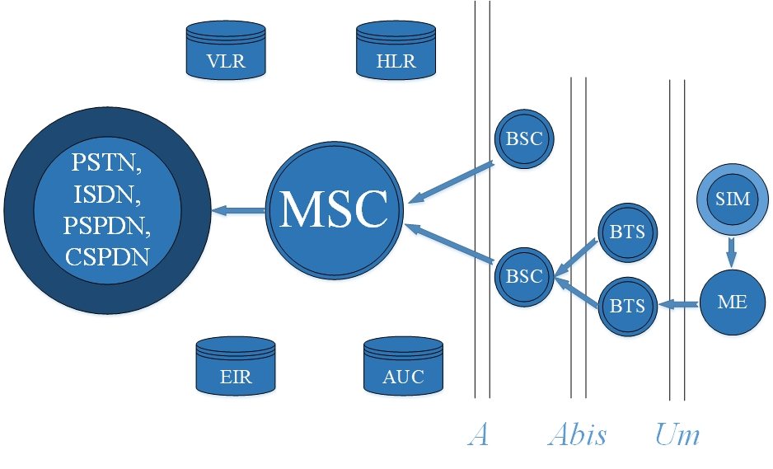

**Figure 2.2:** Architecture of Mobile Communication Systems

**1.**      **The Mobile Subsystem**

The physical equipment, such as the radio transceiver, display, and digital signal processors, as well as the SIM card, make up the MS. In GSM networks, it serves as the user's air interface. As a result, additional services such as voice teleservices, data carrier services, and other supplemental services are available.

In layman's terms, the MS refers to the entire mobile phone device that we carry around with us, which includes both the phone and the SIM card. The subscriber identification module (SIM) allows personal mobility, allowing users to access all subscribed services regardless of terminal location or use. To receive calls on that phone, make calls from that phone, or receive other subscribed services, the SIM card must be inserted into GSM cellular phone.  The home location register (HLR), a functional component of the Network Switching Subsystem (NSS), is usually used to track the content of the SIM card.

**2.**  **The Base Station Subsystem (BSS)**

The BSS consists of two major constituents which are;

* The base transceiver station (BTS).
* The base station controller (BSC).

  The functionalities of the BTS and BSC have been integrated to become the EnodeB (a Huawei technology) because of improvements in the telecommunications sector, particularly in Long-Term Evolution (LTE) technology. Before this, an attempt was made to upgrade the existing system by incorporating 3G technology, which resulted in the introduction of the Radio Network Controller (RNC) and the nodeB (Radio Base Station in 3G), which replaced the BSC and BTS, respectively.

The BTS and the BSC communicate via the Abis interface, allowing operations across components from different manufacturers. A BSS's radio components might range from four to seven or nine cells. One or more base stations can be found in a BSS. Between the BTS and the BSC, the BSS uses the Abis interface. The BSS is then connected to the Mobile Switching Centre (MSC) through a separate high-speed connection (T1 or E1).

·         **The Base Transceiver Station (BTS)**

The BTS manages the radio communication protocols with the MS and houses the radio antennas and sectorial antennas that define a cell. A vast number of BTSs could be placed in a broad urban area. The BTS corresponds to the transceivers and antennas utilized in each cell of the network. A BTS is often located in the cell's centre. The size of a cell is determined by its transmission power. Depending on the number of users in the cell, each BTS has between one and sixteen transceivers. Some of the obligations required of the BTS include the following;

* Encoding, encrypting, multiplexing, modulating, and feeding the RF signals to the antenna
* Transcoding and rate adaptation
* Time and frequency synchronizing
* Voice through full- or half-rate services
* Decoding, decrypting and equalizing received signals
* Random access detection
* Timing advances
* Uplink channel measurements.

**The Base Station Controller (BSC)**

The BSC oversees one or more BTSs' radio resources. Setup of radio channels, frequency hopping, and handovers are all handled by it. The BSC serves as a link between the mobile phone and the MSC. The BSC also converts the 13-kbps voice channel used over the radio link to the regular 64-kbps channel used by the Public Switched Telephone Network (PSTN).

For the MS, it assigns and releases frequencies and time slots. Inter-cell handover is also handled by the BSC. It oversees the BSS and MS power transmission in its territory. The BSC's job is to distribute the required time slots between the BTS and the MSC. It's a radio-switching device that manages radio resources.

**Table 2.2:** **Illustrating Common Network Names; its Core Network Component and Their Respective Network Functionalities**

|  |  |  |
| --- | --- | --- |
| Network Name | Core Network Element | Element’s Functionality |
| 2G | Base Transceiver Station (BTS) | Provide a cellular phone with a radio communication interface. |
| Base Station Controller  (BSC) | Within a GSM network, commands a group of BTSs  When a cellular phone changes from one BTS to another, manage the call handover. |
| 3G | NodeB | In a 3G network, performs BTS tasks. |
| Radio Network Controller  (RNC) | Performs BSC functions in a 3G network. |
| 4G | EnodeB | This device combines the features of both the BTS and the BSC due to technological advancements. |

3.  **The Network Switching Subsystem (NSS)**

The Mobile Switching Centre (MSC) is the key component of the NSS, which handles call switching between mobile and other fixed or mobile network users, as well as management of mobile services including authentication. The network switching subsystem includes the following functional elements;

1. **The Home Location Register (HLR)**: This is a database that stores information about subscribers such as service profiles, location, activity status, and subscription details.
2. **Equipment Identity Register (EIR)**: This is a database that contains information about all the network's operational mobile equipment. Each Mobile Station is identified by its IMEI number.
3. **Authentication Centre (AUC)**: It's an encrypted database that stores a duplicate of the secret key contained in each subscriber's SIM card, which is used for authentication and encryption to keep network operators safe from cellular fraud.
4. **Visitor's Location Register (VLR)**: When subscribers move into another area including another MSC, this database is used to store temporary information about them. The VLR is linked to the MSC, thus when an MS roams into a new MSC area, the VLR attached to the MSC will ask the HLR for the subscriber's information. This allows the VLR to give necessary information for call setup without having to reference the HLR each time.
5. **Mobile Services Switching Centre (MSC)**: This is the most important part of the NSS. It oversees a variety of tasks, including location updates, authentication, handovers, call routing, toll ticketing, network interfacing, and common channel signalling. A unique ID is frequently used to identify it.

Because it is the telecommunications system's brain, the mobile switching centre is extremely important. It connects the two ends of the BSC/RNC/EnodeB to make a connection by checking via the HLR/VLR to authenticate the call initiator and possible recipient. It's frequently housed in a separate data centre with the media gateway and other telecoms system's main components. It is created with a master-slave model, in which the main system is generally responsible for carrying out the defined duty, while the subordinate occasionally takes command to relieve the main of these designated chores to ensure that there is nearly no downtime.

**4.**  **The Operation Support Subsystem (OSS)**

The operation and maintenance centre (OMC) are linked to all switching system equipment as well as the BSC. The operation and support system (OSS) are the name given to the process of implementing OMC. The function of the OMC includes:

1. Administration and commercial operation (subscription, end terminals, charging, and statistics).
2. Security Management.
3. Network configuration, Operation, and Performance Management.
4. Maintenance Tasks.

The network operator watches and controls the system from the OSS, which is the functional entity. The goal of OSS is to provide customers with cost-effective support for GSM network operating and maintenance activities at the centralized, regional, and local levels. The provision of a network overview and support for the maintenance activities of various operation and maintenance groups is a key feature of OSS. The OMC is based on the Telecommunication Management Network's (TMN) rationale and idea.

**2.2.3** **GSM Network Areas**

In a GSM network, the following areas are defined:

* **Cell**: A cell is a basic service area that is covered by one BTS. A Cell Global Identity (CGI) is assigned to each cell, which is a number that uniquely identifies the cell.
* **Location Area**: A Location Area is a collection of cells (LA). When a subscriber receives an incoming call, this area is paged. A Location Area Identity (LAI) is assigned to each LA. One or more BSCs are assigned to each LA.
* **MSC/VLR Service Area**: The area covered by one MSC is called the MSC/VLR service area.
* **PLMN**: The area covered by one network operator is called the Public Land Mobile Network (PLMN). A PLMN can contain one or more MSCs (Tutorials point, n.d.).

### **2.3** **Base Station Energy System**

With the rising penetration of wireless voice and data transmissions into rural places, communication services have encountered several obstacles. One of the most difficult difficulties that telecommunications companies face while constructing their networks is the power supply. Because industrialized countries have well-established electricity infrastructure, this obstacle is easily overcome able. When a national electrical grid exists in a developing country, it is always the preferred energy source for powering BTSs. Unfortunately, it is not always dependable and only covers a small portion of the country (Adediran et al., 2015).

Telecommunications providers in developing nations must produce their power to meet this problem. Currently, diesel generators are being used to address the problem of low electrical supply at Nigerian telecommunications facilities. However, these generators are linked to a slew of issues. These include, among other things, fuel transportation and storage, which is a big issue in rural regions, generator noise pollution, and environmental contamination. During operation, diesel generators emit hazardous hydrocarbons into the environment. Waste heat, which is effectively wasted energy, is also produced by generators. Diesel particulate emissions are a short-lived climatic pollutant that contains a significant amount of black carbon, which has negative health impacts on people (respiratory diseases and eye problems). They create significant levels of health-harming Particulate Matter (PM) and CO2 emissions per kWh of electricity generated, contributing to air pollution and climate change (Manisalidis et al., 2020)

**2.3.1** **Energy Costs in Telecommunication Industries**

Telecommunication network operators' energy expenditures are one of their most significant operating expenses. Energy expenditures account for more than half of mobile carriers' operational expenses, with tower site equipment accounting for around 65 percent of this (From Ericsson, 2008). The issues of delivering energy to these growing networks are increasing as an ever-increasing number of people throughout the world become linked via fixed and mobile telecommunications networks. Telecommunication networks are still predominantly powered by fossil fuels, and energy expenditures constitute a considerable part of their running costs.

In Nigeria, the number of third-generation (3G) and fourth-generation (4G) base transceiver stations (BTS) has risen from 30,000 to 53,460. This means that each BTS will be equipped with a single diesel generator. With the current state of the diesel market, the pump price of the product is N808.87 per litre as of December 29, 2022. For a diesel generator consuming approximately 1500 litres per month. Telecommunications operators will have to spend a whopping N778.32 billion to fuel their 53,460 generators annually. If they buy diesel at N808.87 a litre on a monthly average of N64.86 billion; this huge cost of diesel was in addition to other logistical costs incurred in procuring and transporting the product, as well as the cost of servicing the generators. Renewable energy adoption as an alternative source of electricity by the Nigerian government and network providers will dramatically lower GSM prices.

When weighing the costs and advantages of installing renewable energy solutions to power base stations, mobile operators consider capital expenditures and operating expenses, as well as the time it will take to recoup capital expenditures through operating expense reductions (payback period). According to a study conducted by mobile operator Mobile Telephone Network (MTN) on running 10 BTS in Uganda on solar energy, the average capital expenditure per BTS is around US$49,000, resulting in annual savings of the order of US$15,000 and a payback period of around three years, though the latter figures vary depending on diesel prices (David Taverner & Areef Kassam, 2010). Although the payback period will be affected by the real load (i.e., the total energy consumption of each base station). On several of its facilities in Mozambique, mobile provider Mozambique Cellular (Mcel) has replaced diesel generators with 100 percent solar-powered equipment. It claims to have saved US$405,000 in yearly operational expenditures since 2010, with a capital investment payback of roughly 12 months per location (Isabelle Gross 2012). When oil prices are low, the payback period is extended — typically a couple of years for most renewable energy installations. When oil prices are high, the time it takes to get a return on investment is shorter. The latter comparison represents a significant loss for network providers. Isabelle stated that the cost of operating diesel-powered base stations has increased by 27% since January 2011, particularly in areas without electricity and in western Kenya, where frequent power outages force the stations to run on diesel for up to four hours per day. She also stated that rising operating costs must be addressed, and one way to do so will be to increase calling rates. One strategy is to charge clients more; however, this technique has significant drawbacks. A pricing increase, for example, may result in reduced call volumes and, as a result, no gain in overall income(Ani & Anayochukwu, 2015).

**2.3.2** **Environmental Impact and Greenhouse Gas Emissions**

Many environmental challenges are being experienced across the world because of the use of fossil fuels. Diesel generators have a significant environmental effect due to their continual CO2 emissions during their service life. The annual fuel consumption of a diesel generator used to power a BTS is approximately 18,000 litres. One litre of diesel fuel emits 2.68kg of carbon dioxide (CO2). This produces 46.5 tons of CO2 each year (Ani & Anayochukwu, 2015). The capacity to use a mobile phone "at any time" always necessitates network availability. In Nigeria, diesel generators are used as the primary source of electrical power for over 99 percent of cell sites. The 10.7 kW per base station that we chose to model represents 92.715MWh per year, which would result in 98.793 tonnes of CO2 being released if generated by natural gas (Ani & Anayochukwu, 2015), thus contributing to global greenhouse gas (GHG) emissions. Renewable energy has been recommended as an alternative energy source for these reasons, based on research and developments (Ani & Anayochukwu, 2015)

There is no longer any justification for polluting the environment to achieve economic objectives. It's always simpler to do the right thing for the environment when it also makes financial sense. The use of renewable energy is an efficient strategy to address the energy crisis and pollution issues (Zahedi, 1994). Alternative energy sources for wireless base stations, on the other hand, are eco-friendly alternatives that use cost-effective, dependable, and sustainable power-generating methods for both on- and off-grid areas. Renewable energy solutions have a good impact on the environment. Currently, there are over 10,233 renewable-powered BTSs in operation, reducing global carbon emissions by 480,000 metric tons per year.

In 2008, the GSM Association (GSMA) brought together nearly 800 mobile operators from around the world to announce a plan to install renewable energy sources in 118,000 new and existing base stations in developing countries, saving 2.5 billion litres of diesel and reducing CO2 emissions by 6.3 million tons per year (Mancuso & Alouf, 2011). By switching to solar power on some of its base stations, the Mozambique mobile Mcel project claims to have saved over 5,000 tonnes of CO2. Mobile Telecommunications (MTC) Limited, Namibia's largest mobile operator, swapped its diesel generator for a dual solar-wind power system in one pilot BTS which provides an annual saving of 4.58 tonnes of CO2 per year (Isabelle Gross, 2010).

**2.3.3****Energy Consumption at a Macro Base Transmitter Station Site**

We utilized a macro BTS as a model to determine energy usage at GSM base station locations and analyse the impact of various operating tactics. A BTS is a tower or mast with telecommunications equipment (such as an antenna, radio receiver, and transmitters at the top of the mast) that allows mobile signals to be transmitted and received (voice and data). A shelter with extra transmission equipment, air conditioning, battery racks, and a diesel generator in a separate room is located at the bottom of each tower for individuals who are off-grid or have an intermittent electrical source. Multiple factors influence the load profile of a BTS, including radio equipment, antennas, power conversion equipment, transmission equipment, and so on. As a result, it is critical to sketch out a precise power profile before choosing energy components and sizing them. The various components' energy usage at a typical BTS has been classified (Gildert & Sc, 2006). The following is the categorization:

1. **Radio Equipment:**

* Remote Radio Unit (RRU) [Radio Frequency (RF) Conversion and Power Amplification] = 4160W
* Baseband Unit (BBU) [Signal Processing and Control] = 2190W

1. **Power Conversion System:**

* Power Supply & Rectifier = 1170W

1. **Antenna Equipment**

* Radio Frequency (RF) feeder = 120W
* Safety, Security and Remote Monitoring (aircraft warning light) = 100W

1. **Power Transmission Equipment**

* Signal Transmitting = 120W

1. **Climate Change Equipment**

* Air Conditioning = 2590W

1. **Auxiliary Equipment**

* Security and Lighting = 200W

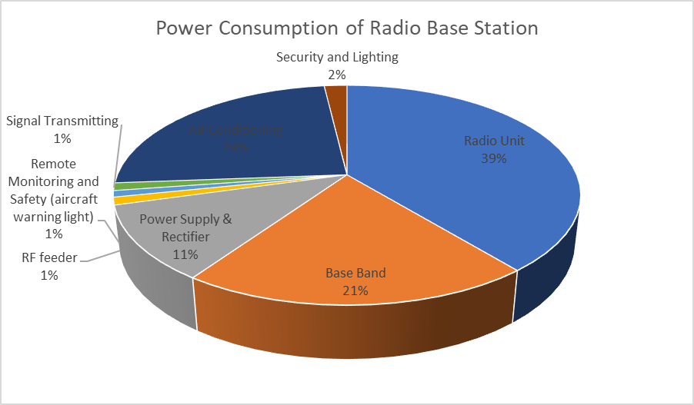This implies that a site consumes **10.7kW** of Electricity. (Gildert & Sc, 2006)

**Figure 2.3**: Power Consumption of Radio Base Station

### **2.4****Power Solutions for BTS Sites**

When it comes to power solutions for remote cell sites, a service provider has a variety of possibilities. The best remedy will be determined by the local conditions and may include:

**2.4.1Mains Power**

It's possible that this is already accessible, or that it can be offered via grid extension. However, when the main grid is the easily available and a stable power supply is available, this will usually be the preferred approach. A battery backup unit is offered in some circumstances where the power supply is often interrupted. New grid connections can be set up in challenging areas, but they are highly expensive.

**2.4.2****Diesel Generators**

Generators (fuelled by gasoline, natural gas, or LPG) are commonly built to create electrical energy, particularly in locations where the power supply is not consistent to assure uninterrupted service delivery. Maintenance and fuel expenses are the two most significant drawbacks of using generators. Again, the inaccessibility of many of these regions adds to operational costs by requiring fuel transportation (Sanjiv Gopal et al. 2011). The generators and accompanying fuel may be a target for theft due to their mobility and high value.

**2.4.3****Renewable Energy Solution**

There are a variety of cost-effective alternative renewable energy sources available if a site is not linked to the main electrical grid or where the electricity supply is intermittent (Ericsson, 2007). Solar energy is one of the most commonly available renewable energy sources, and it is already used as an energy source in Nigeria. Renewable energy sources provide a feasible option for rural power generation (Setiawan et al., 2009). Using alternative energy sources such as solar, wind, hydro, and biofuels will improve communications while reducing dependency on fossil fuels and lowering environmental consequences.

### **2.5** **Renewable Energy Technologies**

Renewable energy is based on the principles of sustainability, renewability, and pollutant reduction (Ericsson, 2008). Renewable energy refers to any source of energy that is not derived from the burning of fossil fuels. Renewable energy systems are built to run on an almost limitless or replenishable supply of natural "fuels," promoting sustainable development. Renewable energy plants provide value to a country's entire resource base by generating electricity from the country's resources and powering base stations.

**2.5.1** **Renewable Power Options at BTS Sites**

The location in which the plant is located influences the renewable energy alternatives available. For example, the performance of solar and wind energy systems (alone or in combination) is greatly influenced by the local climate. Reliability, cost, and the environment are also important considerations when selecting a renewable power source for GSM BTS stations. BTS may be able to use renewable energy sources such as:

* Solar Power
* Wind Power
* Pico Hydro
* Biomass

These energy sources can be utilized as the primary energy source in BTS or as a complement to a grid or Gen-set power. Power supply at the BTS, on the other hand, can be provided by a hybrid system that combines one or more renewable energy sources with diesel-generated hybrid systems, as will be discussed in this paper.

**2.5.2****Hybrid Power Systems (HPS)**

A hybrid-powered system is an electrical production system that combines two or more types of electricity-producing sources (for example, solar photovoltaic panels, wind turbine generators, pico-hydro plants, and/or fuel generators) (Wichert, 1997). Solar photovoltaic panels, wind turbines, and diesel generators are all relevant components of hybrid systems explored in this study. A diesel generator can generate energy at any time, but PV and wind energy are highly dependent on solar radiation and wind speed, respectively. This increases the system's (generator's) reliability and allows it to be used when PV and/or wind are insufficient to meet the load and the battery storage is depleted. Hybrid power systems can be a suitable approach to provide electricity to many rural locations in the developing world, where large-scale electrical grid development is difficult and diesel fuel transportation costs are relatively high.

Telecommunication systems require a safe, long-lasting, and uninterruptible power supply to offer uninterrupted service. Telecommunication networks cannot be powered by stand-alone homogeneous renewable energy systems. The deployment of renewable energies for telecommunications (especially for cell sites) will necessitate a combination of renewable energy sources, conventional generators (Diesel generators), and energy storage systems (battery banks) that are chosen based on their comparative advantage while maintaining an uninterrupted supply and acceptable power quality, hence the HPS may be operated in a variety of modes. Conventional System Source (2) may be utilized in conjunction with Renewable System Source (1) to produce the requisite 10.7kW of power, or either could be used as a backup in the event of a breakdown. Another method of operation is that sources (1) and (2) both have a capacity of 10.7kW, but the supply is alternated so that source (1) provides power for the first 12 hours and source (2) provides power for the remaining 12 hours. When renewable (solar-PV or wind) and generator systems are implemented, this arrangement might successfully reduce carbon emissions by 50%.

Using complex system control logic, a hybrid system coordinates when power should be generated by renewable energy and when it should be generated by sources such as diesel generators (also known as a dispatch strategy). The actual breakthrough of hybrid power generation is the realization that cost savings are achieved by properly matching the cheapest energy output with the load, rather than by using the most powerful solar panels or the most efficient diesel engine. By linking and coordinating sources, the system produces more dependable and higher quality power at reduced rates.

Nigeria's telecoms energy system has progressed to a hybrid system level, combining solar energy with an existing diesel generator and utility power supply to cut operating costs. Integrating wind power with the telecommunications sector to power Nigeria's base station can improve efficiency. Because wind energy is a popular, sustainable, and renewable energy source with a lower environmental effect than burning fossil fuels. Many individual wind turbines are linked to the electric power transmission network to form wind farms.

Wind-generated almost 1600 TWh of power in 2020, accounting for nearly 5% of global electrical output and 2% of global energy consumption. Global installed wind power capacity surpassed 730 GW in 2020, with over 100 GW added largely in China. Analysts think it should develop far quicker - by more than 1% of annual power output - to help reach the Paris Agreement targets to reduce climate change.

On-land wind farms are less expensive than new coal or gas facilities, but fossil fuel subsidies limit wind power growth. On land, wind farms have a larger visual effect than conventional power plants since they must be spread out across more territory and integrated with telecommunication base stations. Small onshore wind farms can offer power to isolated off-grid sites or feed some energy into the BTSs. Offshore wind farms provide a more consistent and powerful source of electricity while also having a lower aesthetic effect. Offshore wind power is growing, even though there is less of it now and that building and maintenance costs are greater. Wind power is a form of renewable energy that is changeable in nature. The electric-power network can be prepared for the predicted changes in output that occur thanks to weather forecasting. In an open-air stream, wind power is related to the third power of the wind speed; when the wind speed doubles, the available power rises eightfold. As a result, wind turbines generating grid electric generation must be exceptionally efficient at higher wind speeds (Wikipedia, 2022).

In the absence of these, a diesel generator (DG) will be employed only when an emergency power source is required. There will be an automatic switchover in power supply between photovoltaic, wind, and DG; with these in place, the telecommunication power system's effectiveness and efficiency will be perfect.

### **2.6** **Wind Power Prediction Using Machine Learning (ML)**

         Wind power is a renewable energy source noted for its unpredictable, chaotic, and erratic supply (Peng et al., 2021). It is critical to forecasting when it will be available in abundance. For this reason, valuable data such as temperature, precipitation (primarily rainfall), humidity, vapor pressure, evaporation, and evapotranspiration, as well as wind speed and direction can be gotten from Numerical Weather Prediction (NPF) online or from Nigerian Meteorological Agency (NIMET) situated in Nigeria (NIMET, n.d.).

         Physical methods, statistical approaches, and artificial intelligence approaches are the three types of wind power forecast, according to (Lin & Zhang, 2021). To begin with, the physical technique, which is most times regarded as the Numeric Weather Prediction method (NWP), is a typical information-driven strategy that uses complex mathematical models of weather data like temperature, pressure, surface roughness, and obstacles to predicting the weather based on current weather conditions, which is known to have excellent forecasting effectiveness in long-term wind speed and not ideal for short-term prediction because they are used once or twice daily since they operate best with supercomputers [A Review of Wind Power and Wind Speed] (Wang et al., 2021).

         The statistical approach, on the other hand, is recognized for its rigorous mathematical link between inputs and outputs and is developed to address the issue of Numerical weather forecast that solely uses the equations for atmospheric dynamics to make predictions that do not determine weather conditions accurately. The statistical method which exploits and minimizes the errors in previous wind speed data know as time-series-based models and are not based on a pre-defined mathematical model. Although it is noted for its prediction accuracy since its calculation time is short with the smallest amount of data available, the disadvantage is that it does not fit well in non-linear sequences (Wang et al., 2021).

Finally, the introduction of Artificial Intelligence has transformed all fields of study, which forecast Wind speed almost accurately and efficiently for both short and long-term prediction. Also, it has been proved by many scholars based on its ability to address the volatility and randomness that characterize wind power. Machine learning is a branch of artificial intelligence that allows a computer program to learn from previous data and adapt or anticipate new data without the intervention of a person (Jake Franckenfield, n.d.). Ensemble learning, Reinforcement learning, Supervised learning, Unsupervised learning, and Neural Networks are the five primary aspects depicted in the diagram below (trekhleb, n.d.) of Figure 4. Each of these categories has its own set of classifications that are considered while constructing a model that is appropriate for one's task and the size of the data (trekhleb, n.d.).

**Figure 2.4**: Machine-learning Classification

Furthermore, the use of Deep learning (DL) also known as Neural networks in comparison with Machine Learning (ML) has now become more prominent because DL can learn features from the data by itself and captures all non-linear relationships while ML must generate its own feature engineering. Also, DL can learn explicitly without any human intervention compared to ML and does this by learning from the environment and past mistakes. However, ML is used mostly to train smaller data sets using CPU (Central Processing unit) which requires shorter training time but gives lower accuracy and linear correlations residuals [Deep Learning for Time Series Forecasting]. Wind Speed being a non-linear data works better when used with DL or neural networks as further explained below.

### **2.7** **Time-Series Forecasting**

A time series is a set of measures collected at even intervals of time and ordered chronologically. The values are obtained at constant intervals of time which might be in form of trends, seasons, and irregular components known as residuals [Deep Learning for Time Series Forecasting]. Time-series data can be predicted or forecasted using Recurrent Neural networks (RNNs) which is a sub-section of Neural Networks of Machine learning. RNNs are specifically designed to deal with sequential data such as sequences of words in problems related to machine translation, audio data in speech recognition, or time series in forecasting problems [Deep Learning for Time Series Forecasting]. The types of RNNs commonly used for time series forecasting are Elman RNN (ENN), LSTM (Long short-term Memory), GRU (Gated Recurrent Unit), Bidirectional RNN (BRNN), Deep RNN, and CNN (Convolutional Neural Network), where each RNN model has its applications. [Deep Learning for Time Series Forecasting] analysed how each model has been applied in various research works, whereby LSTM and GRU models has been used frequently to give better prediction in the renewable energy sector.

### **2.8   Review of Related Works**

         This section reviews the four major stages of Machine Learning algorithms namely; Data collection, Data processing, Model Development, and Model Evaluation (and their results) based on Nigerian case studies and recent journals of research done in other countries additionally, the review of telecommunication base station (BTS) energy consumption is not left behind.

#### **2.8.1** **Data Collection**

In this section, the datasets of past works are subdivided into five, namely: Data type based on existing (old) or recent data, Location, Input-Output Variable, Sampling heights and time, and the amount of data along with the years of each dataset.

The research on wind speed in Nigeria involved collecting data from various states and transferring it to the Nigerian Meteorological Agency (NIMET) in Lagos. The data was collected using cup-generator anemometers at different heights, mostly at 10m hub height (Fadare, 2010) and occasionally at 4m height (Kamgba et al., 2017)). Data were collected from different regions in Nigeria, including the southeast, southwest, central, and southern regions, over periods ranging from 4 to 37 years (Oyedepo et al., 2012). The data were collected at different intervals, ranging from daily to 30-minute intervals, depending on the location and study (Kamgba et al., 2017). The collected data included wind speed and wind power density measurements, and covered periods from 1980 to 2018, with different cities and stations being used as case studies in various studies (Fadare, 2008).

Furthermore, a total of 5110 wind speed datasets were collected from 2m and 50m heights above ground in thirteen different cities in central and southern Nigeria, spanning a ten-year period from 2009 to 2018 (Ben et al., 2021). Additionally, wind speed data covering 13 years from 1995 to 2007 was obtained from Enugu (Odo et al., n.d.) and data spanning 24 years from 1983 to 2007 was collected from southwest region cities (Ajayi et al., 2014). In summary, Table 1 shows a comprehensive overview of wind speed data in Nigeria from various locations and periods.

Several studies from different countries have utilized wind speed or wind power data collected from various sources. For example, (Kumar et al., 2022) obtained data from Siahpoush Wind Farm in Fuzhou, China, spanning from 1973 to 2020, and Haikou, China, spanning from 1973 to 2014 (Wu et al., 2022a). (Zhang et al., 2022) collected 5000 data points from Hainan Province, China, from May to June 2020. (Sun & Jin, 2022) collected air pressure, temperature, humidity, dew point, and wind speed direction data from Wellington, San Francisco, and Phoenix cities, covering the period from 2004 to 2012 with sampling times ranging from 3 to 24 hours.

Some studies also obtained data from meteorological websites of respective countries, such as Kaggle and MERRA websites in Portugal (Khan et al., 2022), and "The National Renewable Energy Laboratory (NREL)" of the "U.S. Department of Energy" in the United States (Rahman et al., 2022). However, the sampling time of the data collected may vary across locations, ranging from 10 minutes, 15 minutes, 30 minutes, and even hours and seasons, as shown in Table 2, in studies b (Patel & Deb, 2022) y, (Khan et al., 2022), and (Meng et al., 2022), unlike Table 1, which focuses on sampling height.

#### **2.8.2 Data Pre-Processing**

         This stage is widely recognized as the most important aspect in the development of machine learning algorithms because the input data collected from various wind farm stations needs to be processed effectively to achieve accurate training and prediction outcomes. Different techniques, such as data cleaning, filtering, outlier detection, inputting missing data, feature selection, and data reshaping (normalization and standardization), have been widely used in recent research papers, depending on the datasets being utilized. Although, as regards the research conducted in Nigeria, there was not a specific pre-processing method adopted.

In contrast, other research studies conducted in different nations utilized different approaches for processing their datasets. For example, (Xu et al., 2022) used a four-stage data-cleaning approach for their wind speed data. This involved removing unnecessary data based on thresholds, arranging and grouping sampled data using quartiles, eliminating wind power data exceeding a pre-set threshold using longitudinal quartiles, and further eliminating abnormal data through two-stage clustering analysis. The cleaned data was then categorized into gale and breeze seasons based on wind speed.

On the other hand, (Khazaei et al., 2022) proposed a three-step forecasting method for processing NWP (numerical weather prediction) data. The first step involved outlier detection using T2 statistics after clustering the datasets using automatic clustering. The second step included normalization and decomposition of the datasets into low and high-frequency signals using discrete Meyer wavelet transform (dmey WT). Lastly, NSGA-II (Non-dominated Sorting Genetic Algorithm II) in combination with RBF (Radial Basis Function) neural network was utilized for feature selection based on dominance or crowding distance criteria.

Furthermore, in the study conducted by (Wu et al., 2022), the datasets were initially cleaned to address missing values and outliers using SPSS software. Linear interpolation was used to fill in the missing values. The data was further processed in three stages to prepare it for the model. First, different types of correlation coefficients were used to extract essential input variable features, and then a t-test was applied to filter out variables with lower correlation coefficients. Auto and partial correlation were also used to select relevant hyperparameters for the model network.

Similarly, in the study by (Rahman et al., 2022) datasets without missing values or outliers were filtered using irrelevancy and redundancy filters, with pre-set thresholds determined through trial and error. The resulting features were transformed and scaled using normalization to bring them to the same range. In contrast,(Zhang et al., 2022) only performed normalization and splitting of the datasets into training and testing sets. Some research studies, such as (Che et al., 2022), (Wang et al., 2022), (Ding et al., 2022), and (Ye et al., 2022), have utilized various decomposition and filter techniques to extract useful features from datasets. For instance, Che et al. used VMD (Variational Mode Decomposition) and Kalman filter, while (Wang et al., 2022) and (Ding et al., 2022) employed EEMD (Empirical Mode Decomposition) and VMD, respectively.(Wang et al., 2022) and (Ding et al., 2022) also utilized a combination of decomposition and optimization techniques, using SAE (Stacked Autoencoder) and BA (Bat Algorithm) to decompose the data and select optimal modes of features. Additionally, used a combination of WT (Wavelet Transform) for decomposition and IGFCM (Improved Gravitational Fuzzy Clustering Method) for obtaining optimized weights through wave clustering and matching techniques, respectively. The datasets in these studies were divided into training and testing datasets for wind farms A and B.

#### **2.8.3 Model Development**

         This is a crucial step in machine learning and data analysis, where collected and pre-processed data is used to build predictive or descriptive models. Various techniques, such as algorithm selection, model training, hyperparameter tuning, and performance evaluation, have been employed by different researchers during this process. The 2-parameter Weibull distribution function model, which is part of the conventional statistical model, has been widely used in research papers focusing on Nigeria's datasets and has shown good accuracy in most studies, as shown in Table 1. However, in (Fadare, 2010), Artificial Neural Network (ANN) was used for wind speed prediction instead of the Weibull model.

In contrast to research conducted in Nigeria, other studies in different nations have used various methods for wind energy prediction. Some researchers have used a combination of statistical and Artificial Neural Networks (ANN) to improve prediction accuracy. For example, (Xu et al., 2022) used a Wiener model, which combines ARX and FNN networks, resulting in high accuracy. (Sun & Jin, 2022) proposed an ARIMA-FNN hybrid model that selects useful features and trains the model using minimum error.

Time-series regression models have also been employed by several researchers for higher prediction accuracy. (Wang et al., 2022) used a combination of Support Vector Regression (SVR) and Bidirectional Long Short-Term Memory (BiLSTM) models with optimization techniques to correct predictions and optimize hyper-parameters. (Rahman et al., 2022) used the NARX model with gradient-descent optimization and other hyper-parameters for multi-step wind speed prediction. (Khazaei et al., 2022) used MLP neural network with LM and EPB algorithms for training, although MLP was not sensitive to input feature dependencies.

Some researchers have worked on improving RNN types, such as using Residual GRU and CSO for training and retraining datasets (Ding et al., 2022). (Wu et al., 2022) used a GRU model with selected input variables and hyper-parameters and tested for accuracy using hypothesis tests. (Ye et al., 2022) worked on LSTM, a Seq2Seq deep learning model for predicting future information based on past data. Other approaches proposed by researchers include using swarm intelligence with ANN (IWOA-FLN model) for optimized weights parameters (Zhang et al., 2022), and using a multi-scale model that combines WRF and OpenFOAM for high-resolution datasets (Che et al., 2022) as an improvement to the NWP model.

#### **2.8.4 Model Evaluation**

This is an important step in the process of developing and implementing predictive models. It involves assessing the performance and accuracy of a model in predicting outcomes based on a given dataset, which helps in making informed decisions about model selection, hyperparameter tuning, and model deployment for real-world applications.

The studies reviewed so far have commonly used a set of error metrics to evaluate the performance of their models as shown in Tables 1 and 2. These metrics include Root Mean Squared Error (RMSE), Mean Squared Error (MSE), Mean Absolute Error (MAE), Mean Absolute Percentage Error (MAPE), R-squared (R), R-squared adjusted (R2), and Chi-squared (χ2).

Table 2.1 in this research showed that (Kamgba et al., 2017) achieved a correlation coefficient of 0.89 for wind speed and temperature, and -0.88 for wind speed and humidity, indicating an inverse relationship between wind speed and humidity. (Fadare, 2010) obtained a Mean Absolute Percentage Error (MAPE) of 8.9% and a Correlation Coefficient (R) of 0.9380 between predicted and measured wind speed values. The predicted monthly wind speed ranged from 0.9 to 13.1 m/s with an annual mean of 4.7 m/s. Other studies in the table also reported specific results on average monthly, annual, or seasonal wind speed or power as part of their model evaluation or assessment.

Table 2.2 of the cited journals evaluated their models using various metrics such as MAE, MASE, MAPE, and RMSE, except for (Zhang et al., 2022) who used PICP, PINRW, and PIAD. Most of the studies made wind power predictions on an hourly and daily basis, with some using day-ahead predictions. Many of these studies compared their models with benchmark models to validate their accuracy. For example, (Ye et al., 2022) compared their model with nine benchmark models and achieved close to 100% accuracy for CR and QR, with average NRMSE and NMAE error metrics of 14% and 10.3% respectively. (Wang et al., 2022) compared their proposed model with a combination of three to five models extracted from their model, which resulted in better prediction results with RMSE, MAE, and MAPE error metrics of 0.046, 0.034, and 28.93% respectively for Gaolan Wind farm, and 0.038, 0.029, and 22.13% respectively for Lanzhou Wind farm, among others.

**Table 2.3: Nigeria’s Case Studies**

|  |  |  |  |  |  |  |
| --- | --- | --- | --- | --- | --- | --- |
| REFERENCE | DATA COLLECTION | | | | MODEL DEVELOPMENT | MODEL EVALUATION |
|  | Year | Location | Input-Output Variable | Sampling Heights |  |  |
| (Kamgba et al., 2017) | 12 hrs daily for 14 days. | Calabar | Wind Speed, Relative Humidity and Temperature | 4m | None | R and R² |
| (Oyedepo et al., 2012) | 24-37 years | South-east Enugu, Owerri and Onitsha | Wind Speed | 10m | Weibull distribution function | Not Specified |
| (Fadare, n.d.) | 10 years (1995-2004) | International Institute of Tropical Agriculture (IITA), Ibadan. | Wind Speed | 10m | Weibull distribution function | R2, RMSE, and COE |
| (T et al., 2017) | 31 years (1980-2010). | Ikeja. | Wind Speed and Wind Power Density | Wind Speed=10m Wind Power Density= 50m | 2-parameter Weibull distribution function model | R2, χ2, RMSE and COE |
| (Ben et al., 2021) | 10 years (2009–2018) | Enugu, Nsukka, Ogoja, Gboko, Makurdi, Ilorin, Abuja, Otukpo, Udi, Ikwo, Lafia, Afikpo, and Obudu. | Wind Speed | 2m and 50m above the ground. | 2-parameter Weibull distribution function | RMSE, R2, MBE and MAPE. |
| (Ben et al., 2021) | 4 years (2008–2011) | Calabar, Uyo, Warri, and Ikeja Stations. | Wind Speed | 10m | Weibull and Rayleigh probability density function and cumulative distribution function | RMSE and  χ2 |
| (Odo et al., n.d.) | 13 years (1995 – 2007) | Enugu | Wind Power | 10m | 2-parameter Weibull distribution function | R |
| (Olayinka, 2011) | 21 years (1986-2007) | Uyo | Wind Speed | 10m | Weibull and Rayleigh Distribution Function. | R2, X^2, RMSE and COE. |
| (Ajayi et al., 2014) | 24 years (1987- 2010) | South West in Lagos and Oyo States | wind speed | 10m | 2-parameter Weibull distribution | Not Specified |
| (Ajayi, Fagbenle, & Katende, 2011) | 21 years  (1987- 2007) | Sokoto. | Wind Speed | 10m | 2-parameter Weibull distribution function | R2, RMSE and COE |
| (Ajayi et al., 2013) | 21 years  (1987- 2007) | Kano, north-western  Nigeria. | Wind Speed | 10m | 2-parameter Weibull distribution function | R2, RMSE and COE |
| (Fagbenle et al., 2011) | 21 years (1987- 2007) | Maiduguri and Potiskum, in North-East | Wind speed | 10m | 2-parameter Weibull distribution function | R2 |
| (Ajayi, Fagbenle, Katende, et al., 2011) | 21 years 1987-2007 | Jos, Plateau | Wind Speed | 10m | 2-parameter Weibull distribution function | R2, RMSE  and COE |
| (Amoo, 2012) | 20 years 1990-2010 | Abeokuta and Ijebu-Ode | Wind Speed | 10m | 2-parameter Weibull distribution function | RMSE, COE and R2 |
| (Adaramola & Oyewola, 2011) | 12-20 years (1983-2007) | Oyo state | Wind Speed | 10m | Rayleigh Distribution Model. | Not Specified |
| (Adaramola et al., 2014) | 9-37 years | Niger Delta; Ikom, Ogoja, Calabar, Port Harcourt, Warri, Benin-city and Asaba | Wind Speed | 10m | 2-parameter Weibull distribution function | Not Specified |
| (Fadare, 2010) | 20 years (1983–2003) | 28 ground stations;  training (18 stations) and testing (10 stations) | Wind Speed | 10m | ANN Artificial Neural Network | MAPE and R2 |

**Table 2.4: Other Countries’ Case Studies**

|  |  |  |  |  |  |  |  |
| --- | --- | --- | --- | --- | --- | --- | --- |
| Reference | Data Collection | | | | Data Processing | Model Development | Model Evaluation |
|  | **Year** | **Location** | **Input-Output Variable** | **Sampling Time** |  |  |  |
| [(Ding et al., 2022)](https://docs.google.com/document/d/1RywNGiBquef8KL4_7SjKufUE2k0jooci/edit#bookmark=id.35nkun2) | Dec 2021 | Belgium | Wind power/ Speed | 15min | EEMD | EEMD-LSTM-SVR. | MAPE, MAE, MSE, SMAPE and RMSE |
| [(Rahman et al., 2022)](https://docs.google.com/document/d/1RywNGiBquef8KL4_7SjKufUE2k0jooci/edit#bookmark=id.1hmsyys) | 2007-2013 | NREL of the U.S. Department of Energy | Pressure, temperature, wind speed, and wind direction.  Output =Wind speed while others are input | Minutes, Hours and Days | Irrelevancy filter and  redundancy filter | NARX-NN neural network | MSE and R2 |
| [(Khazaei et al., 2022)](https://docs.google.com/document/d/1RywNGiBquef8KL4_7SjKufUE2k0jooci/edit#bookmark=id.1y810tw) | 2014 | Sotavento, Spain. | Wind direction, Wind speed, and wind power | 10min | Wavelet Transform. | Outlier detection- WT- Feature Selection-MLP | NRMSE and NMAE |
| [(Sun & Jin, 2022)](https://docs.google.com/document/d/1RywNGiBquef8KL4_7SjKufUE2k0jooci/edit#bookmark=id.vx1227) | 2004-2012 | Wellington, San Francisco and Phoenix | Air-pressure, temperature, humidity, dew point, and wind speed direction | 3-24 hours | Not Specified | ARIMA-FNN | RMSE and MSE |
| [(Meng et al., 2022)](https://docs.google.com/document/d/1RywNGiBquef8KL4_7SjKufUE2k0jooci/edit#bookmark=id.3whwml4) | January, April, July, and October 2016 | Spain | wind power, wind speed and wind direction | Seasons; Winter, Spring, Summer and Autumn | EEMD | EEMD-BA-RGRU-CSO | MAE, RMSE and R2 |
| [(Che et al., 2022)](https://docs.google.com/document/d/1RywNGiBquef8KL4_7SjKufUE2k0jooci/edit#bookmark=id.lnxbz9) | 2019 | Houhoku, Japan | Wind Speed | 1 hour | VMD | VMD-LSTM-KF | ME, MAE and RMSE |
| [(Li et al., 2022)](https://docs.google.com/document/d/1RywNGiBquef8KL4_7SjKufUE2k0jooci/edit#bookmark=id.2xcytpi) | Jan, March, July and October 2017 | Mahuangshan, Ningxia. | Wind power, wind speed, wind direction, temperature, barometric pressure, and humidity | 15min | VMD and FPA | Two stage forecasting method of VMD-FPA-BILSTM- IMFs-PCA (bi-directional long short-term memory) | MAE, MAPE and RMSE |
| [(Wang et al., 2022)](https://docs.google.com/document/d/1RywNGiBquef8KL4_7SjKufUE2k0jooci/edit#bookmark=id.19c6y18) | Not Specified | Hexi Corridor area, China | Wind speed | Not Specified | VMD | SAE-VMD-CS-LWSM-SVR-BiLSTM-BiGRU | MAPE, MAE and RMSE |
| [(Ye et al., 2022)](https://docs.google.com/document/d/1RywNGiBquef8KL4_7SjKufUE2k0jooci/edit#bookmark=id.37m2jsg) | Jan- Dec 2017 | Northeast China | Wind Power | 15 min  3-4 day ahead | Wave Division (WD)and Feature Extraction | WD-IGFCM-LSTM | MAE and RMSE |
| [(Xu et al., 2022)](https://docs.google.com/document/d/1RywNGiBquef8KL4_7SjKufUE2k0jooci/edit#bookmark=id.nmf14n) | 2018 | SCADA system in Yalova, Turkey | Wind speed | 10min | Correlation based neuro-fuzzy two-stage cluster analysis | Wiener-type model | MAE, MAPE, MSE and RMSE |
| [(Wu et al., 2022)](https://docs.google.com/document/d/1RywNGiBquef8KL4_7SjKufUE2k0jooci/edit#bookmark=id.28h4qwu) | Fuzhou (1973-2020) and Haikou (1973-2014) | Fuzhou and Haikou. | Wind speed | A day | Clustering and linear interpolation method | GRU network | MAPE and MSE |
| [(Zhang et al., 2022)](https://docs.google.com/document/d/1RywNGiBquef8KL4_7SjKufUE2k0jooci/edit#bookmark=id.1mrcu09) | 5000 data  points from May to June, 2020 | Hainan Province, China | Wind Power | 10min | IWOA | IWOA-FLN | PICP, PINRW and PIAD |

### **2.9** **Summary**

         Nigeria's telecommunication industry has undergone several changes in recent years with the deployment of 5G technology commercially available in Nigeria, coupled with the increment in the number of base transceiver stations (BTS) from 30,000 to 53,460 (according to the information stated by Nigerian Communications Commission (NCC) in 2021). Mostly, these BTS are powered by Diesel Generators and cause a lot of harm than good. To address the problem associated with Telecommunication industry and to reduce the amount of greenhouse gases affecting our climate, it is important to dive into the wealth of Renewable Energy the country has been blessed with, and this will provide solutions to the Sustainable Development Goal 3,7,8,9,11,13,15, and 17 which are good health and well-being, affordable and clean energy, decent work and economic growth, industry, innovation, and infrastructure, sustainable cities and communities, climate action, life on land and partnerships for the goals respectively

The use of wind Energy which is part of the Hybrid Power System solution is the focus of this literature review whereby the following points was noted in the journal cited above, namely:

1. Nigeria is known to have abundance and prospect of Wind Energy potentials most especially in the Northern region of Nigeria on On-shore areas like Jos, Sokoto Kano, and Maiduguri etc.
2. Also, in offshore areas from South-west and South-east region of Nigeria also have potentials for harvesting strong wind energy throughout the year.
3. All Journals published with Nigeria’s datasets collected their respective Datasets from NIMET while other countries' datasets were collected from their respective countries' wind farm stations.
4. The use of a 2-parameter Weibull distribution function has all been used to predict wind energy while various Machine Learning models like ANN, Deep, and Shallow learning models have also been used in other countries.
5. About Nigeria’s case studies, it was only (Fadare, 2010) that used ANN (Artificial Neural network) for its Wind speed prediction which obtained MAPE of 8.9% and correlation coefficient (r) between the predicted and the measured wind speed values of 0.9380. This will serve as the baseline model for this research work.
6. Model evaluations such as RMSE, MSE, MAE, MAPE, R, R2, and χ2 were all used to assess each journal's model for both Nigeria's and Other Countries’ Datasets.
7. Lastly, Research has shown that wind speeds in the north range from 4.0 to 7.5 m/s at a height of 10m. Similarly, wind speeds in the southern area of Nigeria are modest, ranging from 3.0-3.5 m/s. Furthermore, despite the projected potential of offshore regions, there is no single offshore station among the 44 stations administered by the Nigerian Metrological Agency.

In this study, a novel data processing approach is developed along with the common LSTM time-series model because of the datasets obtained from NIMET which was univariate wind speed data. Feature engineering techniques were used to engineer the univariate wind speed data to predict a multi-variate LSTM model. In addition, the proposed model was also compared with other benchmark models to ascertain the model's prediction accuracy.

# CHAPTER THREE

## METHODOLOGY

This section describes the features of the region of study as well as the wind speed forecasting process such as processes of data collection, data pre-processing, forecasting model development, and model evaluation.

**Figure 3.1**: Methodology Block Diagram

### **3.1** **Area of Study**

Nigeria as a country constitutes four regions as North-west, North-east, North-central, South-west, South-east, and South-south. The province of Kano is located (as shown in Figure 3.1), in the Southern part of the Sahara Desert of the Sudan savanna region, south of the Sahel, which coincides with the North-western part of Nigeria of the location 12.0022° N, 8.5920° E (Wikipedia, n.d.). Kano has a tropical savanna climate with about 980 mm of precipitation per year, the majority of which falls from June through September, Kano is very hot and windy. The windier part of the year ranges from November to July with an average wind speed of 11.86 miles per hour (5.30 metres per second). The windiest month in the year is February with an average wind speed of 16.8 miles per hour (7.5 metres per second). The calmest month ranges from July to November with an average wind speed of 8.9 miles per hour (4.0 metres per second) (NiMet, n.d.).

### **3.2 Wind Speed Forecasting Process**

#### **3.2.1 Data Collection**

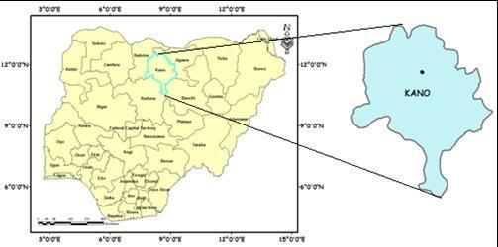The wind speed data used in this study was provided by the Nigeria Meteorological Station (NIMET), located in Oshodi, Lagos state, Nigeria. This station archives all the meteorological data for the entire nation. A cup-generator anemometer was used to measure the wind speed in Kano State, Nigeria every day from 2008 to 2017 at a hub height of 10 meters. A cup-generator anemometer which the simplest comprises three or four spinning cups was used to measure the wind speed in Kano State, Nigeria, every day from 2008 to 2017 at a hub height of 10 meters. The operation process is shown in Figure 3.2 below, where the Wind strength increases as the cups spin more quickly. The average wind speed for each day was used to calculate the recorded wind speeds. The time steps in (day-month-year) format and the daily Wind speed make up the two columns of the wind speed data that have been collected.

**Figure 3.2**: Map and Location of Kano in Nigeria

Short-term wind speed forecasting is essential, particularly for the telecommunication industry, as off-grid power plants are required at every base transceiver station (BTS). Forecasting the electricity quantity from wind within the day is crucial because it is necessary to know the electricity amount and the equivalent price in a transparent platform. The data supplied were prepared according to the appropriate procedures and applied to the models.

**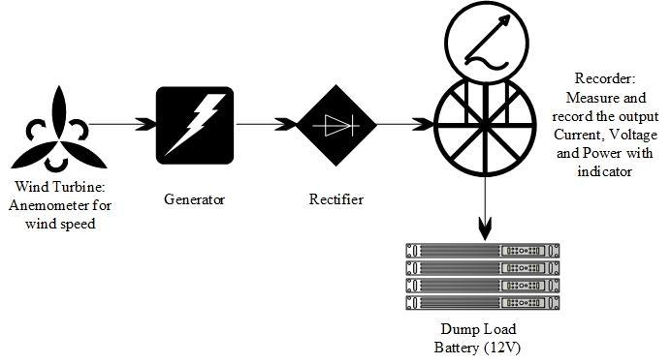****Figure 3.3**: Wind Speed Measurement Process

#### **3.2.2 Data Pre-processing**

Pre-processing is the first step in data science and machine learning in solving categorization and information retrieval challenges. Before any machine learning algorithms process the data obtained from NIMET, the unprocessed data will first go through pre-processing procedures. Data reduction, data transformation, and data cleaning are the three different types of data pre-processing techniques (Technická univerzita (Košice et al., n.d.). Data cleaning is used to remove missing data. Data transformation covers feature engineering, data normalization, domain-level transformation, and other related topics. Dimensionality reduction, attribute subset selection, and other topics are covered under data reduction (Antony et al., 2021). While data cleaning is a necessary step in any data-related project, data transformation and data reduction are problem-dependent processes among the three strategies. However, the dataset (used for this study) does not require any Data cleaning process since it does not contain any missing values and outliers. Hence, the following section describes the Data transformation techniques used for this study in detail.

**Data transformation:** The purpose of doing this is to offer an alternate representation of the data, which will result in a better (more accurate) model than one produced by using the data in its original format. Normalization and feature engineering, or selection, are the two techniques used.

**Normalization:** This is the process of converting the columns in a dataset to the same or a common scale without losing information or distorting variations in the ranges of values. Every dataset does not need to be normalized for machine learning. Only when features have various ranges, for it to be necessary. For a machine learning model representation to be effective, both columns must have the same scale.

**Feature Engineering:** This is a crucial step in data pre-processing, particularly for time-series data such as Wind Speed. In this study, the approach to feature engineering involved data reconstruction, which is essential for dealing with chaotic time-series data. The primary goal of data reconstruction is to recover a high-dimensional data space, and the method used in this study is reshaping the time-series data. The reason for this approach is that the prior chaotic data contains unknown information, and LSTM models, which will be used in this study, are highly sensitive to errors. Therefore, the reshaping method of reconstruction (RMR) was employed to achieve wind speed time-series data reconstruction, which will allow the LSTM model to learn from the previous day and predict the following day's wind speed values sequentially.

According to RMR, assuming the data dimension is *j* and the delay time is *t* the reconstructed phase space time-series data  *will be*

Based on the rearrangement of data using the RMR method, the data reconstruction process can be viewed as the rearrangement of data from a single set of chaotic univariate time series data, as illustrated in Figure 3.4. By implementing this method, the LSTM model that will be developed can learn from the previous day's data and make sequential predictions for the following day.

The following steps are utilized in feature engineering:

**STEPS:**

***Step 1:*** Data rearrangement as illustrated above.

***Step 2:***  Mapping and reshaping the input data alongside mapping with output data, for the LSTM to learn from the series of observations. They are divided into different examples to make it easier for the model to identify patterns and make predictions.

***Step 3:*** Both X and Y arrays are split into Training and Testing Datasets. Hence, the meteorological data are split into training and testing and testing datasets, based on the day ahead prediction as shown in Table 3.1.

**Table 3.1 Data splitting**

|  |  |  |  |
| --- | --- | --- | --- |
| Wind speed | Dataset | Samples | Sample percentage |
|  | Whole | 3657 | 100% |
|  | Training | 2558 | 70% |
|  | Test | 1099 | 30% |

**Data transformation**: The purpose of doing this is to offer an alternate representation of the data, which resulted in a better (more accurate) model than one produced by using the data in its original format. Standardization and feature engineering, or selection, are the two techniques used.

***Standardization:*** This is also known as Z-score and will be used to restructure the Wind speed dataset to a uniform format. It is a variation of scaling that represents the number of standard deviations () away from the mean ().

Mathematically, the Formula is given as:

Where

#### **3.2.3 Forecast Model Development**

The Long-Short-Term Memory Algorithm (LSTM), a type of Recurrent Neural Networks (RNN) that is suitable for time-series forecasting, will be used to develop a forecast model for estimating daily wind speed based on pre-processed Wind Speed (WSP) data. The data at this stage is a single series of observations, and the LSTM model will learn from the series of previous observations to predict the following value in the sequence, making it useful for one-step univariate time series forecasting and prediction. Additionally, the LSTM model can be adapted and used as the input component of a model for various types of time series forecasting problems. Prior to simulating the univariate series, it must first be prepared where the LSTM model will learn a function that converts a series of previous observations from input to output. To train the LSTM, the series of observations must be divided into different examples, resulting in a Univariate LSTM Model.

**LSTM Model**

A memory cell is added to the hidden layer of an RNN model to control how the time series' memory data is stored. The LSTM is a subclass of the RNN model and has three different parts: forget, input, and output control gates. Two of these gates control the state of the LSTM memory cell. The input gate controls the fusion of information and stimuli and defines how much input from the current instant can be saved, while the forget gate shows how much memory from the previous moment can be saved. The output gate is primarily used to regulate the volume of data supplied for cell status. The sent data travels to various cells in the hidden layer through the programmable gates. This makes it possible to manage how much past and present knowledge is remembered and forgotten as shown in Figure 3.3.

The LSTM network's structure is shown in Figure 3.4. Equations (1) through (3) represent the sigmoid function, which has a value between zero and one, where 1 means everything passes and 0 means nothing passes. The hyperbolic tangent function is used to solve the gradient disappearing issue. The subscript t denotes the time step, and the subscripts I, f, and o denote the input, forgetting, and output, respectively (Yan Follow, 2016). The LSTM has a long-term memory function and does not experience gradient disappearance, in contrast to the RNN. The equations are given as follows:

Where ***Wf*, *Wi*, *Wo*** and ***Wc*** provide weight matrices for the forgetting gate, input gate, output gate and memory cell; respectively. ***Uf*, *Ui*, *Uo*, *and Uc*** express the weights of the recurrent connections of the forgetting gate, input gate, output gate and memory cell; respectively. **xt** represents the LSTM network's input vector at a certain time step ***t***, ***ft*** denotes the forget gate's activation vector, ***it*** represents the input gate's activation vector, and ***ot*** is the output gate's activation vector, which represents the element-wise multiplication. ***čt*** and **ct** represent the activation vectors for the cell's input and state. Here, the **bf, bi, bo** and **bc** represent the forgetting gate bias vector, input gate bias vector, output gate bias vector, and memory cell bias vector; respectively. The sigmoid function *σ*(x) and the hyperbolic tangent function *σh*(x) are defined as follows:

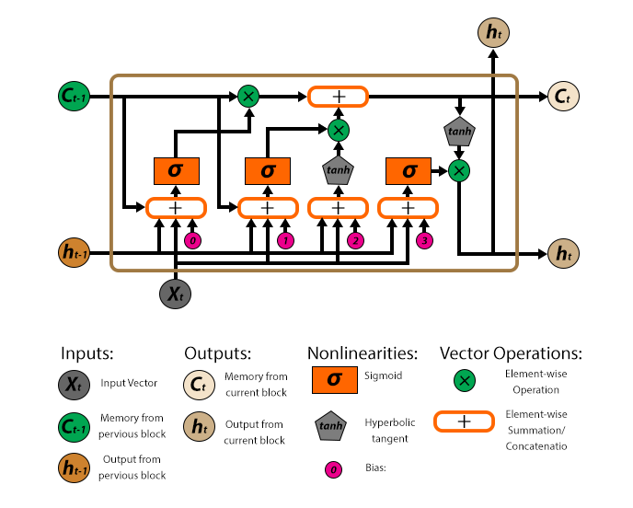

**Figure 3.4**: LSTM Model Chart, Source: (Rukshan Pramoditha, 2022)

**LSTM Hyperparameters**

Hyper-parameters are variables whose values regulate how a machine learning model learns. These variables are established before the model begins its learning process, and they help the model learn better. Below is a discussion of the hyper-parameters that were employed in this research to fine-tune the LSTM model:

1. **Number of Neurons and LSTM Hidden Layers**: The hidden layers, which are located between the input and output layers, contain the neurons or nodes of the network. The number of nodes or hidden layers to be used depends on the complexity of the problem being solved. In this research, a trial-and-error method was employed to determine the optimal number of hidden neurons and layers to achieve better results. For simple problems, one hidden layer with a few nodes may be sufficient, while for more complex issues, two or more hidden layers may be necessary. However, using too few nodes may result in underfitting, while using too many nodes could lead to overfitting. Regularization techniques can be employed to mitigate this issue by adding constraints to the network's weights. In summary, selecting the appropriate number of neurons and hidden layers is crucial in achieving the desired results. A careful consideration of the complexity of the problem and the use of trial-and-error methods to fine-tune the model can result in a more accurate and effective LSTM model.
2. **Activation Functions:** The input Layer, Hidden Layer(s), and Output Layer are the three types of layers that are commonly present in a neural network. Since no calculations are made in the input layer, it only stores the incoming data. As a result, there is no activation function employed. Deep learning models can learn non-linear prediction bounds by introducing non-linearity inside hidden layers of a neural network using activation functions. However, the application determines which activation layer to use (Rukshan Pramoditha, 2022).  The following will be a brief discussion of the activation layers employed in this study:

**Table 3.2 Description of activation Functions used in the LSTM model**

|  |  |  |
| --- | --- | --- |
| Function | Description | Mathematical expression |
| Sigmoid activation function | The graph of this non-linear function is s-shaped. It is also known as the logistic function and it is employed in models of logistic regression (Classification models).  The input is transformed into a probability value between 0 and 1 via the sigmoid function. |  |
| Tanh activation function | It is a non-linear function, just like the sigmoid function. The graph of the Tanh function is s-shaped, but its gradient is steeper than that of the sigmoid function. The fact that the tanh function is zero-centered over the sigmoid function is one benefit of utilizing it. This greatly simplifies the optimization procedure. The tangent hyperbolic function's output is always between -1 and +1. |  |
| ReLU activation function | An excellent substitute for the sigmoid and tanh activation functions is the ReLU (Rectified Linear Unit) activation function. The convergence of ReLU is six times faster than that of the sigmoid and tanh functions, and the learning rate is also faster, both of which contribute to this function's low computing cost. The ReLU function is thought to consist of two linear components. The ReLU function is a piecewise linear function, yet it is nonetheless non-linear, as a result. |  |
| Purelin activation function | It is a linear function (named f) that multiplies the input by the constant c to produce the output, cz, from the input, z. No changes are performed to the input before the function returns it. A linear function has a single straight line as its graph. | . When c=1 |

1. **The number of Epochs**: How many full iterations of the dataset are to be run is determined by this hyperparameter. Theoretically, this number can be adjusted to an integer value between one and infinity; using the trial-and-error method, it should be increased until the validation accuracy starts to drop even as the training accuracy rises (thus risking overfitting). Although no particular value is necessary for the increment, the addition of 5 values will be utilized to gauge training accuracy and was then gradually raised after that.
2. **Batch Size**: This hyperparameter specifies how many samples must be examined before the model's internal parameters are changed. In comparison to smaller ones for the same number of samples, larger sizes produce larger gradient steps. However, 32 is often used depending on the number of features and datasets but multiples of 8 will be employed in the experiment to test the model's training accuracy.
3. **Loss function**: : Machines learn through a loss function. It is a method of evaluating how well a specific algorithm models the given data. If predictions deviate too much from actual results, the loss function will output a very large number. For this time-series forecasting problem, the following loss functions was used:

**Table 3.3 Description of loss Functions used in the LSTM model**

|  |  |  |
| --- | --- | --- |
| Function | Description | Mathematical Expression |
| MSE (Mean square error) | It is quantified as the average squared difference between expectations and actual observations, as the name suggests. It doesn't care which way the errors are going; just their average magnitude is important. | Where, Predicted value, Real or actual values and n= number of observations. |
| MAE (Mean Absolute Error) | It is calculated as the mean of the sum of the absolute discrepancies between predicted and observed data. Like MSE, this estimates the size of the error without taking their direction into account. Unlike MSE, MAE requires more sophisticated tools to compute the gradients, such as linear programming, and is more resistant to outliers because it does not employ a square. | Where, Predicted value, Real or actual values and n= number of observations. |
| MSLE (Mean Squared Logarithmic Error) loss | The MSLE calculates the ratio of the actual value to the expected value. The error curve becomes asymmetric as a result. Only the percentage difference between the actual and anticipated values is important to MSLE. | Where, Predicted value, Real or actual values and n= number of observations. |
| Log-cosh Loss | The hyperbolic cosine of the prediction error is the logarithm of the log-cosh loss function. It is a different function that is substantially smoother than MSE loss and is utilized in regression jobs. | Where, Predicted value, Real or actual values and n= number of observations*.* |

1. **Optimizers**: It modifies the weights and learning rate of model’s neural network using algorithms or other techniques to minimize losses (Poudel et al., 2018). The LSTM model was experimented with and tuned using the following sorts of optimizers:
2. **SGD (Stochastic Gradient Descent)**: It is a variation of gradient descent, and it functions by often updating the model's parameters. The model parameters in this are changed when the loss on each training example is computed.
3. **Adagrad (Adaptive Gradient Algorithm):** Unlike all previous optimizers, this one modifies the learning rate ‘η’ for each parameter and at each time step. It uses the derivative of an error function and is a form of a second-order optimization algorithm.
4. **Adadelta**: It is an Adagrad improvement that tends to fix the declining learning rate issue. Adadelta restricts the window of accumulated past gradients to some specified size weight (w) rather than accumulating all previously squared gradients.
5. **RMSprop (Root Mean Square Propagation)**: The hyper-parameter learning rate that RMSProp maintains is adjusted based on the recent average magnitudes of the gradients for the values of the weights, such as how quickly they are changing. It resembles Adadelta a lot. The way they handle the previous gradients is the only thing that differs.
6. **Adam and variants (Adamax & Nadam)**: Adam (Adaptive Moment Estimation) deals with first- and second-order momentums. The idea behind the Adam is that the velocity is slightly reduced for a thorough examination. The Adam update incorporates a bias correction technique in addition to looking similar to RMSProp except that a smooth version of the gradient rather than the raw stochastic gradient (SGD) is employed. Additionally, Adam maintains an exponentially declining mean of previous gradients M. (t). The first moment's mean is represented by M(t), and the gradients' uncentered variance is represented by V(t).
7. **Number of Timesteps**: As previously stated, the number of prior observations needed to estimate the future daily prediction in time-series forecasting determines the timesteps employed by the LSTM model. In this study, the timesteps will be incrementally increased from 1, 2, 3,..., and 20 to identify the precise number that would ultimately yield the best forecast.
8. **Dropout layer**: This refers to as dropping out nodes or neurons (input and hidden layer) in the LSTM model architecture. Here, the range of 0.1 to 0.9 (10% to 90% of the neurons) will be varied to test the values that will give the best prediction accuracy.

**3.2.4** **Short-Term wind speed forecasting**

This section employs the LSTM architecture to predict wind speed, as shown in Figure 6, and outlines the steps for training, validation, and testing the model. The dataset is divided into training and testing sets during pre-processing. The model is then trained using the training set with randomly selected hyperparameters, such as the number of neurons, layers, activation functions, dropout, optimizer, and epochs, to refine the prediction using the cross-validation set. The trained model is then evaluated and applied to predict wind speed using the test data samples. The hyperparameters are refined until the model produces the least RMSE and other performance metrics, and the predicted values are plotted alongside the test samples.

#### **3.2.5 Model Evaluation**

The Root Mean Square Error (RMSE), Mean Absolute Error (MAE), Mean Square Error (MSE), Mean Absolute Percentage Error (MAPE), and coefficient of determination - Score (R2) were used to evaluate the model's performance. These metrics help to determine the level of accuracy achieved by the model and to decide when to adjust the hyperparameters. For instance, if the RMSE was high, the hyperparameters and the number of timesteps were adjusted in a stepwise manner until an acceptable level of accuracy was achieved. The equations below are used to calculate these measures:

Where, Predicted value, Real or actual values, ȳ is the average value of the observed output over samples existing and n= number of observations.

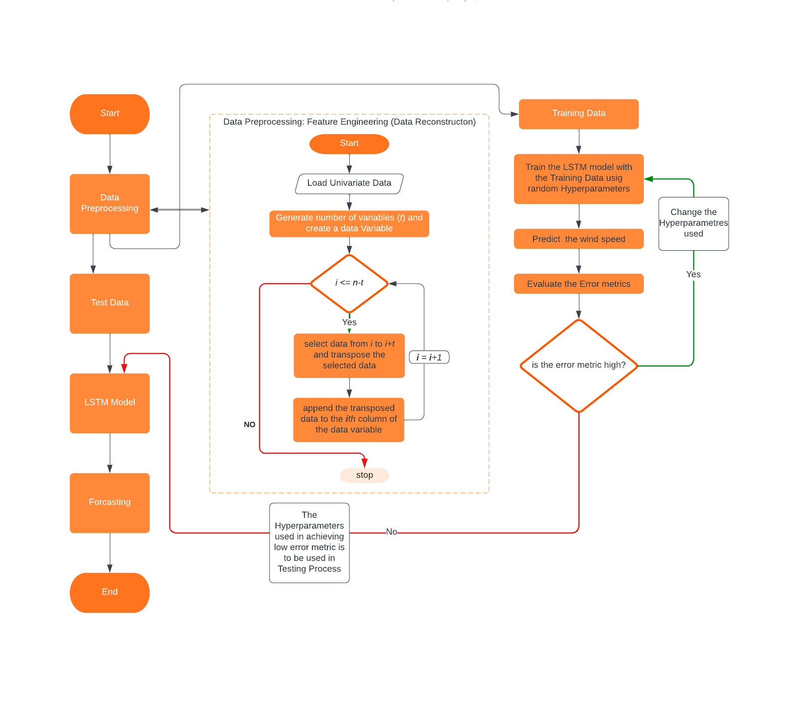**Figure 3.5:** Process of Wind Speed Prediction

# CHAPTER FOUR

## RESULTS AND DISCUSSION

In this section, the results of the study are presented in accordance with the stated aims and objectives. Due to the unavailability of other meteorological parameters and NIMET's confidential policy, this study uses only wind speed as an input variable. However, the data processing conducted in the previous chapter allowed for a good prediction accuracy of the proposed model. Additionally, the processed data was utilized for training and testing the LSTM (Proposed) model. The performance of each LSTM hyper-parameter was evaluated using error metrics and compared with previously developed algorithms. This chapter is structured as follows: Part A presents the statistical description of the datasets, Part B discusses the performance of each LSTM hyper-parameter, and Part C provides a comparison of the proposed model with other models.

In addition to these results, we also examined the compatibility of this process with the existing photovoltaic power generation at telecommunication base stations. We found that by incorporating wind power generation alongside solar power, it is possible to significantly improve the efficiency of sustainable power usage in the telecommunication industry. This has important implications for reducing the carbon footprint of telecommunication networks and promoting the use of clean energy sources.

Overall, our findings suggest that wind speed prediction using the proposed LSTM model can be a valuable tool for optimizing wind power generation in the telecommunication industry. By combining this approach with existing solar power generation, we can work towards a more sustainable future for the telecommunications sector".

### **4.1** **Part A: Description of Datasets**

The wind speed data used in this study was collected by NIMET over a period of 10 years, from 2008 to 2017. The data consists of 3,653 samples, which were divided into two subsets: a 70% training set containing 2,557 samples from 2008 to 2014, and a 30% testing set containing 1,096 samples from 2015 to 2017. [Table 4.1](https://docs.google.com/document/d/1RywNGiBquef8KL4_7SjKufUE2k0jooci/edit#bookmark=id.val1zn9hlkuc) provides a detailed statistical description of the wind speed data. The table includes descriptive measures such as mean, median, mode, standard deviation, variance, maximum, minimum, range, kurtosis, and skewness. The values of these measures were calculated for the entire dataset, as well as for the training and testing subsets. Figures 4.2 and 4.3 show the distribution of the wind speed data in the training and testing subsets. The figures provide an overview of the wind speed data used in this study.

Overall, the wind speed data used in this study exhibit a mean wind speed of 10.37 m/s, with a standard deviation of 4.61 m/s. The maximum wind speed observed was 30 m/s, while the minimum wind speed was 0 m/s. The data has a positive skewness, indicating that most of the wind speed values are located towards the lower end of the distribution. The kurtosis values of the dataset indicate that it is platykurtic, meaning that it has fewer extreme values than a normal distribution.

**Table 4.1: Detailed Description of the Dataset**

|  |  |  |  |
| --- | --- | --- | --- |
| Statistical Information | Dataset (No. of Observations) | | |
|  | **All samples (3653)** | **Training (2557)** | **Testing (1096)** |
| Mean (m/s) | 10.3767 | 11.1807 | 8.5009 |
| Median (m/s) | 10 | 11 | 9 |
| Mode (m/s) | 10 | 10 | 10 |
| Standard Deviation (m/s) | 4.6116 | 4.5497 | 4.1909 |
| Variance (m/s) | 21.2674 | 20.7002 | 17.5634 |
| Maximum (m/s) | 30 | 30 | 22 |
| Minimum (m/s) | 0 | 0 | 0 |
| Range (m/s) | 30 | 30 | 22 |
| Kurtosis (m/s) | 0.1575 | 0.2802 | 0.0186 |
| Skewness (m/s) | 0.0288 | -0.0127 | 0.0009 |

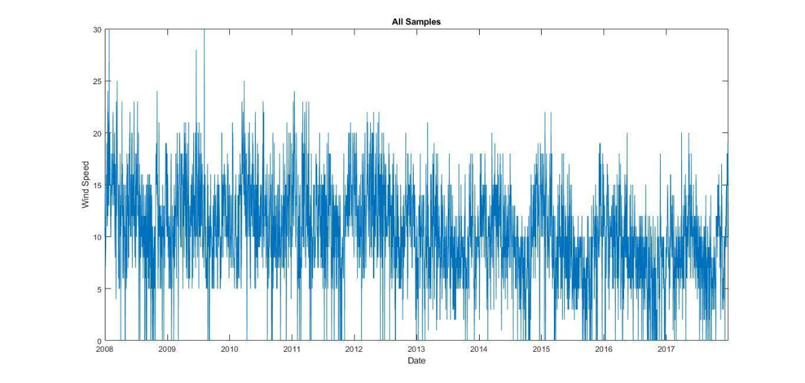**Figure 4.1:** All Data Samples

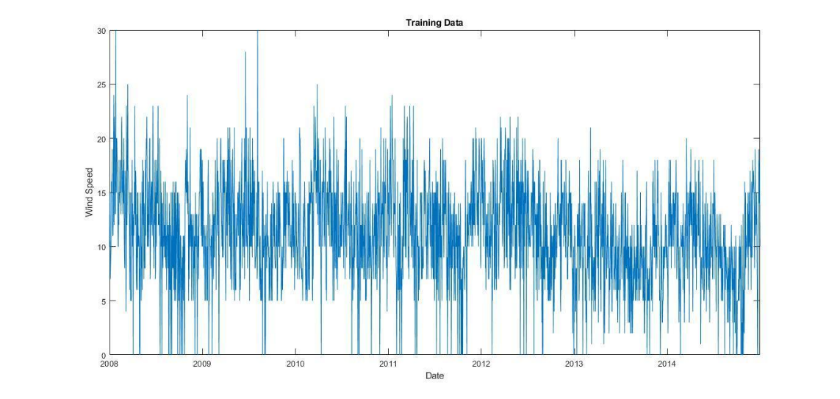

**Figure 4.2:** Training data

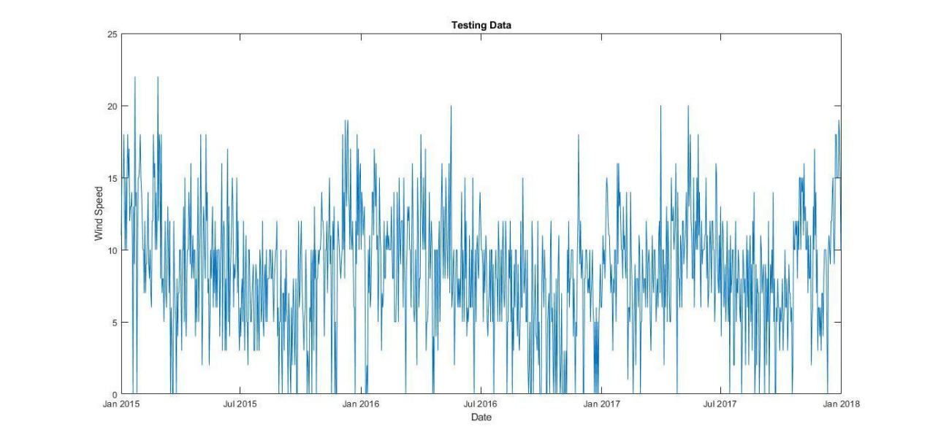

**Figure 4.3:** Testing data

### **4.2** **Part B: Performance of each LSTM hyper-parameters**

From the previous chapter, it was noted that the performance of LSTM models is affected by their hyper-parameters. The hyper-parameters include the number of hidden neurons and LSTM layers, activation functions, optimizers, loss functions, batch sizes, and dropout. These hyper-parameters were experimented with and evaluated using various error metrics such as MAPE, MAE, MSE, R2, and RMSE, as shown in Tables 4.2 to 4.7. Furthermore, Table 4.8 to 4.10 shows the performance evaluation of the Time-steps, engineered feature, and the number of Epochs respectively. From this result, the number of time-steps of 1 showed the best performance evaluation in Table 4.8, and then 6-engineered features and 20 epochs gave the best performance evaluation in Table 4.9 and 4.10 respectively. Each table of the results was further analyzed and compared based on the error metrics used.

Table 4.2 shows that as the number of hidden neurons increases from 1 to 40, the performance metrics generally improve, with decreasing values for MAPE, MAE, MSE, and RMSE, and increasing values for R2. However, after 40 hidden neurons, the performance begins to decrease, with some metrics showing higher values for larger numbers of hidden neurons. This suggests that there is an optimal number of hidden neurons for this neural network that maximizes its predictive power. Overall, the neural network seems to perform well, with low values for all metrics. However, the best performance is achieved with 40 hidden neurons, which results in the lowest MAPE, MAE, MSE, and RMSE, and the highest R2. Therefore, this number of hidden neurons is likely the optimal choice for this neural network.

**Table 4.2: Performance Evaluation of Varying Hidden Neurons**

|  |  |  |  |  |  |
| --- | --- | --- | --- | --- | --- |
| Hidden neurons | MAPE | MAE | MSE | R2 | RMSE |
| 1 | 0.1053 | 0.8470 | 1.8510 | 0.8089 | 1.3605 |
| 2 | 0.0863 | 0.5971 | 0.9788 | 0.9372 | 0.9893 |
| 3 | 0.0985 | 0.7118 | 1.14080 | 0.9296 | 1.0681 |
| 4 | 0.0871 | 0.5488 | 0.6494 | 0.9626 | 0.8058 |
| 5 | 0.0734 | 0.4391 | 0.4852 | 0.9716 | 0.6965 |
| 6 | 0.0705 | 0.3737 | 0.3190 | 0.9824 | 0.5648 |
| 7 | 0.0635 | 0.3116 | 0.2145 | 0.9889 | 0.4632 |
| 8 | 0.0639 | 0.3204 | 0.2475 | 0.9864 | 0.4975 |
| 9 | 0.0628 | 0.2704 | 0.1571 | 0.9917 | 0.3964 |
| 10 | 0.0630 | 0.2881 | 0.1804 | 0.9899 | 0.4247 |
| 11 | 0.0635 | 0.2791 | 0.1634 | 0.9914 | 0.4043 |
| 12 | 0.0552 | 0.2039 | 0.1115 | 0.9940 | 0.3338 |
| 13 | 0.0612 | 0.2403 | 0.1034 | 0.9948 | 0.3215 |
| 14 | 0.0548 | 0.2017 | 0.0947 | 0.9950 | 0.3078 |
| 15 | 0.0545 | 0.2040 | 0.1002 | 0.9946 | 0.3164 |
| 16 | 0.0544 | 0.1996 | 0.0840 | 0.9956 | 0.2899 |
| 17 | 0.0566 | 0.2182 | 0.1132 | 0.9938 | 0.3364 |
| 18 | 0.0518 | 0.1617 | 0.0514 | 0.9973 | 0.2269 |
| 19 | 0.0534 | 0.1859 | 0.0801 | 0.9956 | 0.2830 |
| 20 | 0.0529 | 0.1679 | 0.0617 | 0.9967 | 0.2484 |
| 21 | 0.0521 | 0.1742 | 0.0651 | 0.9967 | 0.2551 |
| 22 | 0.0523 | 0.1576 | 0.0456 | 0.9976 | 0.2135 |
| 25 | 0.0553 | 0.2023 | 0.0798 | 0.9957 | 0.2825 |
| 30 | 0.0531 | 0.1478 | 0.0433 | 0.9978 | 0.2081 |
| 40 | **0.0480** | **0.1133** | **0.0244** | **0.9987** | **0.1563** |
| 50 | 0.0482 | 0.1234 | 0.9983 | 0.9984 | 0.1761 |
| 60 | 0.0557 | 0.1832 | 0.0567 | 0.9973 | 0.2383 |
| 70 | 0.0448 | 0.0857 | 0.0147 | 0.9992 | 0.1214 |
| 80 | 0.0457 | 0.0826 | 0.0117 | 0.9994 | 0.1083 |
| 90 | 0.0455 | 0.0933 | 0.0170 | 0.9991 | 0.1304 |
| 100 | 0.0472 | 0.1044 | 0.0175 | 0.9991 | 0.1325 |
| 110 | 0.0442 | 0.0722 | 0.0096 | 0.9995 | 0.0982 |
| 120 | 0.0462 | 0.0879 | 0.0125 | 0.9993 | 0.1120 |
| 130 | 0.0447 | 0.0847 | 0.0153 | 0.9992 | 0.1237 |
| 140 | 0.0468 | 0.1053 | 0.0202 | 0.9989 | 0.1423 |
| 150 | 0.0475 | 0.0990 | 0.0152 | 0.9992 | 0.1234 |

Looking at [Table 4.3](https://docs.google.com/document/d/1RywNGiBquef8KL4_7SjKufUE2k0jooci/edit#bookmark=id.l87hr9tcaobw), it is evident that the ReLU activation function outperforms the other activation functions in terms of MAPE, MAE, MSE, and R2. The ReLU activation function has the lowest MAPE (0.0466), MAE (0.0992), MSE (0.0166), and RMSE (0.1289) values, indicating that it produces the most accurate predictions. Additionally, it has the highest R2 value (0.9991), indicating that it fits the data very well. On the other hand, the Purelin (linear) activation function has the highest MAPE (0.4308), MAE (3.8578), and RMSE (4.8341) values, indicating that it produces the least accurate predictions. It also has a negative R2 value (-92.0108), indicating that it is a poor fit for the data.

The tansig (tanh) and sigmoid (logsig) activation functions perform better than the Purelin (linear) functions but not as well as the ReLU activation function. The tansig function has slightly better MAPE, MAE, and RMSE values than the sigmoid function, but the sigmoid function has a slightly higher R2 value. Overall, the ReLU activation function appears to be the best choice among the four activation functions for this dataset.

**Table 4.3: Performance Evaluation of Activation Functions**

|  |  |  |  |  |  |
| --- | --- | --- | --- | --- | --- |
| Activation Functions | MAPE | MAE | MSE | R2 | RMSE |
| ReLU | **0.0466** | **0.0992** | **0.0166** | **0.9991** | **0.1289** |
| Purelin(linear) | 0.4308 | 3.8578 | 23.3688 | -92.0108 | 4.8341 |
| tansig(tanh) | 0.0481 | 0.1016 | 0.0181 | 0.9990 | 0.1344 |
| Sigmoid(logsig) | 0.0503 | 0.1264 | 0.0280 | 0.9986 | 0.1674 |

Table 4.4 shows the performance evaluation of different optimizers used for the neural network. Among the different optimizers, Adam shows the best performance on most of the evaluation metrics, including MAPE, MAE, MSE, and RMSE. It achieves the lowest values for MAPE, and RMSE, indicating that it is the most accurate optimizer. However, it does not perform as well on the R2 metric as RMSprop and Nadam.

**Table 4.4: Performance Evaluation of Optimizers**

|  |  |  |  |  |  |  |
| --- | --- | --- | --- | --- | --- | --- |
| Optimizers | MAPE | MAE | ME | MSE | R2 | RMSE |
| RMSprop | 0.0505 | 0.1504 | 1.0565 | 0.0409 | 0.9980 | 0.2023 |
| SGD | 0.0703 | 0.3403 | 1.8347 | 0.1921 | 0.9893 | 0.4383 |
| Adam | **0.0483** | **0.1840** | **1.3117** | **0.0601** | **0.9968** | **0.2452** |
| Adadelta | 0.3750 | 3.7196 | 13.7787 | 22.1739 | -158.3691 | 4.7089 |
| Adagrad | 0.2132 | 1.9341 | 8.7132 | 6.1208 | 0.4061 | 2.4740 |
| Nadam | 0.0472 | 0.1058 | 0.8511 | 0.0202 | 0.9989 | 0.1422 |
| Adamax | 0.0629 | 0.2525 | 1.6219 | 0.1116 | 0.9937 | 0.3342 |

Table 4.5 provides a performance evaluation of different loss functions. The Mean Squared Error (MSE) loss function has the lowest MAPE (0.0482) and the highest R2 (0.9989) among all the evaluated loss functions. This suggests that the MSE loss function performs well in minimizing the error and producing accurate predictions.

**Table 4.5: Performance evaluation of loss functions**

|  |  |  |  |  |  |
| --- | --- | --- | --- | --- | --- |
| Losses | MAPE | MAE | MSE | R2 | RMSE |
| Mean Squared Error (MSE) | **0.0482** | **0.1051** | **0.0197** | **0.9989** | **0.1405** |
| Mean Squared Logarithmic Error (MSLE) | 0.0775 | 0.3463 | 0.2062 | 0.9885 | 0.4541 |
| Mean Absolute Error (MAE) | 0.0531 | 0.1806 | 0.0518 | 0.9972 | 0.2277 |
| Huber | 0.0582 | 0.2011 | 0.0537 | 0.9973 | 0.2318 |
| Log cosh | 0.0478 | 0.1085 | 0.0216 | 0.9988 | 0.1471 |

Table 4.6 shows the performance evaluation of varying batch sizes which indicates that as the batch size increases, the MAPE decreases up to a certain point, after which it starts increasing. The lowest MAPE is obtained at a batch size of 48. The same trend can be observed in MAE and RMSE as well. However, the MSE do not show a clear trend with respect to batch size. The R2 values are consistently high across all batch sizes, indicating a good fit for the model.

In conclusion, the choice of batch size depends on the specific problem and dataset, but generally, a batch size of around 48 seems to perform well based on the evaluation metrics used in this table.

**Table 4.6: Performance evaluation of Varying number of Batch-sizes**

|  |  |  |  |  |  |
| --- | --- | --- | --- | --- | --- |
| Number of Batch-sizes | MAPE | MAE | MSE | R2 | RMSE |
| 8 | 0.0503 | 0.1293 | 0.02915 | 0.9984 | 0.1707 |
| 16 | 0.0608 | 0.2301 | 0.0855 | 0.9953 | 0.2924 |
| 24 | 0.0636 | 0.2349 | 0.0916 | 0.9950 | 0.3026 |
| 32 | 0.0498 | 0.1296 | 0.0274 | 0.9986 | 0.1656 |
| 40 | 0.0507 | 0.1477 | 0.0382 | 0.9980 | 0.1956 |
| 48 | **0.0484** | **0.1149** | **0.0231** | **0.9988** | **0.1522** |
| 56 | 0.0618 | 0.2813 | 0.1348 | 0.9922 | 0.3672 |
| 64 | 0.0567 | 0.1866 | 0.0484 | 0.9975 | 0.2201 |
| 128 | 0.0825 | 0.4479 | 0.2615 | 0.9858 | 0.5113 |
| 256 | 0.0683 | 0.3367 | 0.2121 | 0.9889 | 0.4606 |

Table 4.7 shows the performance evaluation of varying dropout values in the neural network model, in which it was observed that the MAPE values increase with increasing dropout rates. The lowest MAPE value is obtained for a dropout rate of 0.1, and the highest MAPE value is obtained for a dropout rate of 0.9. Hence, the best-performing dropout rate is 0.1, which provides the lowest MAPE and MAE values, and the highest R2 value.

**Table 4.7: Performance evaluation of varying Dropout**

|  |  |  |  |  |  |
| --- | --- | --- | --- | --- | --- |
| Dropout | MAPE | MAE | MSE | R2 | RMSE |
| 0.1 | **0.0511** | **0.1436** | **0.0355** | **0.9982** | **0.1885** |
| 0.2 | 0.0520 | 0.1441 | 0.0348 | 0.9982 | 0.1864 |
| 0.3 | 0.0579 | 0.2315 | 0.0858 | 0.9955 | 0.2929 |
| 0.4 | 0.0524 | 0.1764 | 0.0587 | 0.9970 | 0.2423 |
| 0.5 | 0.0715 | 0.3540 | 0.1863 | 0.9902 | 0.4317 |
| 0.6 | 0.0612 | 0.2685 | 0.1217 | 0.9935 | 0.3489 |
| 0.7 | 0.0853 | 0.4200 | 0.2958 | 0.9828 | 0.5438 |
| 0.8 | 0.0781 | 0.3704 | 0.2284 | 0.9874 | 0.4779 |
| 0.9 | 0.1204 | 0.8311 | 0.9889 | 0.9273 | 0.9944 |

As seen in Table 4.8, the MAPE varies from 0.0473 to 0.1113, while the MAE varies from 0.0931 to 0.4272. The MSE values vary from 0.0210 to 0.2791, while the R2 values vary from 0.9855 to 0.9990. The RMSE values range from 0.1449 to 0.5284. From the results, it can be observed that the LSTM model's performance decreases as the number of time-steps increases from 1 to 20. The best performance is observed for one time-step, with the lowest MAPE, MAE, MSE, and RMSE values and the highest R2 value. However, as the number of time-steps increases, the performance metrics gradually decrease, indicating that the model predictive power decreases with an increase in the number of time-steps.

Therefore, it can be concluded that the LSTM model's best performance is observed for one time-step, and an increase in the number of time-steps leads to a decrease in performance.

**Table 4.8: Performance evaluation of Varying Time-steps**

|  |  |  |  |  |  |
| --- | --- | --- | --- | --- | --- |
| Number of Time-steps | MAPE | MAE | MSE | R2 | RMSE |
| 1 | **0.0473** | **0.0972** | **0.0273** | **0.9987** | **0.1652** |
| 2 | 0.0593 | 0.1705 | 0.0465 | 0.9978 | 0.2157 |
| 3 | 0.0956 | 0.1546 | 0.0482 | 0.9979 | 0.2197 |
| 4 | 0.0786 | 0.2660 | 0.1214 | 0.9945 | 0.3484 |
| 5 | 0.0591 | 0.1506 | 0.0471 | 0.9978 | 0.2171 |
| 6 | 0.0576 | 0.1916 | 0.0594 | 0.9970 | 0.2436 |
| 7 | 0.0528 | 0.1479 | 0.0419 | 0.9979 | 0.2049 |
| 8 | 0.0547 | 0.1732 | 0.0618 | 0.9972 | 0.2487 |
| 9 | 0.0601 | 0.1788 | 0.0549 | 0.9975 | 0.2344 |
| 10 | 0.1113 | 0.4272 | 0.2356 | 0.9903 | 0.4854 |
| 11 | 0.0531 | 0.1199 | 0.0316 | 0.9985 | 0.1778 |
| 12 | 0.0656 | 0.1679 | 0.0488 | 0.9978 | 0.2209 |
| 13 | 0.0596 | 0.1926 | 0.0684 | 0.9969 | 0.2615 |
| 14 | 0.0473 | 0.2171 | 0.0702 | 0.9965 | 0.2146 |
| 15 | 0.0572 | 0.1181 | 0.0321 | 0.9985 | 0.1794 |
| 16 | 0.0763 | 0.4160 | 0.2791 | 0.9855 | 0.5284 |
| 17 | 0.0693 | 0.2634 | 0.1192 | 0.9944 | 0.3452 |
| 18 | 0.0645 | 0.2382 | 0.0966 | 0.9950 | 0.3109 |
| 19 | 0.0519 | 0.0931 | 0.0210 | 0.9990 | 0.1449 |
| 20 | 0.0644 | 0.1682 | 0.0494 | 0.9976 | 0.2223 |

Based on Table 4.9, it is evident that the MAPE (Mean Absolute Percentage Error) values decrease as the number of engineered features increases from 1 to 6, indicating that these additional features help improve the accuracy of the model. In general, the results suggest that adding up to 6 engineered features can help improve the performance of the model, but adding too many features can lead to overfitting and decreased performance.

**Table 4.9: Performance evaluation of Varying Engineered features**

|  |  |  |  |  |  |
| --- | --- | --- | --- | --- | --- |
| Number of Engineered features | MAPE | MAE | MSE | R2 | RMSE |
| 1 | 0.3187 | 3.1534 | 15.7880 | -2.0907 | 3.9734 |
| 2 | 0.0537 | 0.2015 | 0.0626 | 0.9966 | 0.2502 |
| 3 | 0.0549 | 0.2156 | 0.0717 | 0.9962 | 0.2678 |
| 4 | 0.0551 | 0.2127 | 0.0823 | 0.9963 | 0.2868 |
| 5 | 0.0527 | 0.1627 | 0.0438 | 0.9979 | 0.2094 |
| 6 | **0.0386** | **0.1123** | **0.0239** | **0.9987** | **0.1547** |
| 7 | 0.0702 | 0.2565 | 0.0989 | 0.9954 | 0.3146 |
| 8 | 0.0652 | 0.2674 | 0.1018 | 0.9949 | 0.3191 |
| 9 | 0.0556 | 0.1623 | 0.0475 | 0.9975 | 0.2181 |
| 10 | 0.0523 | 0.1631 | 0.0469 | 0.9977 | 0.2166 |
| 11 | 0.0569 | 0.2027 | 0.0704 | 0.9962 | 0.2654 |
| 12 | 0.0586 | 0.1704 | 0.0483 | 0.9977 | 0.2198 |
| 13 | 0.0554 | 0.1734 | 0.0469 | 0.9977 | 0.2165 |
| 14 | 0.0443 | 0.1743 | 0.0524 | 0.9971 | 0.2288 |
| 15 | 0.0654 | 0.2705 | 0.1167 | 0.9941 | 0.3416 |
| 16 | 0.05496 | 0.2032 | 0.0711 | 0.9963 | 0.2666 |
| 17 | 0.0633 | 0.2569 | 0.1173 | 0.9942 | 0.3425 |
| 18 | 0.0520 | 0.1872 | 0.0639 | 0.9968 | 0.2527 |
| 19 | 0.0523 | 0.1759 | 0.0541 | 0.9972 | 0.2326 |
| 20 | 0.0623 | 0.2116 | 0.0763 | 0.9960 | 0.2763 |

Table 4.10 shows that as the number of epochs increases, the performance of the model generally improves. The lowest MAPE of 0.0416 is achieved with 20 epochs, and the highest MAPE of 0.0545 is achieved with 5 epochs. Similarly, the lowest MAE of 0.0733 is achieved with 80 epochs, and the highest MAE of 0.1759 is achieved with 5 epochs. The trend is similar for the other performance metrics as well. It is interesting to note that increasing the number of epochs beyond a certain point does not always result in better performance. For example, the MAPE increases slightly from 20 to 30 epochs, and the MAE increases slightly from 80 to 90 epochs, which suggests that there might be an optimal number of epochs that provides the best performance for this model.

Overall, the performance of the model is quite good, with the lowest MAPE of 0.0416 and the highest R-squared value of 0.9994 achieved with 20 and 50 epochs, respectively.

**Table 4.10: Performance evaluation of Varying number of Epochs**

|  |  |  |  |  |  |
| --- | --- | --- | --- | --- | --- |
| Number of Epochs | MAPE | MAE | MSE | R2 | RMSE |
| 5 | 0.0545 | 0.1759 | 0.0525 | 0.9971 | 0.2292 |
| 10 | 0.0482 | 0.1051 | 0.0197 | 0.9989 | 0.1405 |
| 20 | **0.0416** | **0.1199** | **0.0234** | **0.9987** | **0.1531** |
| 30 | 0.0490 | 0.1088 | 0.0260 | 0.9986 | 0.1614 |
| 40 | 0.0431 | 0.1418 | 0.0359 | 0.9979 | 0.1895 |
| 50 | **0.0447** | **0.0823** | **0.0128** | **0.9994** | **0.1135** |
| 60 | 0.0467 | 0.1029 | 0.0189 | 0.9990 | 0.1377 |
| 70 | 0.0450 | 0.0873 | 0.0156 | 0.9992 | 0.1251 |
| 80 | 0.0444 | 0.0733 | 0.0123 | 0.9994 | 0.1110 |
| 90 | 0.0488 | 0.1132 | 0.0257 | 0.9986 | 0.1604 |
| 100 | 0.0441 | 0.0751 | 0.0114 | 0.9994 | 0.1069 |

Finally, Table 4.11 presents the final hyper-parameter results of the LSTM model for wind speed prediction. The LSTM model was trained with 20 epochs, and the final values of the metrics were calculated. The MAPE value obtained for the LSTM model is 0.0416, which indicates that the average percentage error in the predictions is 4.16%. The MAE value obtained is 0.1199, which shows that the model's predictions have an average deviation of 0.1199 from the actual values. The MSE value obtained is 0.0234, indicating that the model's predictions have a small mean squared error. The R2 value of 0.9987 indicates that the model has a high level of accuracy and can explain 99.87% of the variability in the wind speed data. The RMSE value obtained is 0.1531, which indicates that the root mean squared error of the model's predictions is 0.1531. Overall, the LSTM model has shown promising results in wind speed prediction, with high accuracy and low error values.

**Table 4.11: Final LSTM Hyper-parameter Result**

|  |  |  |  |  |  |
| --- | --- | --- | --- | --- | --- |
| Final values | MAPE | MAE | MSE | R2 | RMSE |
| Epochs=20 | **0.0416** | **0.1199** | **0.0234** | **0.9987** | **0.1531** |

Figure 4.4 shows the model’s training loss chart which was observed to give a less error with the given number of epochs.

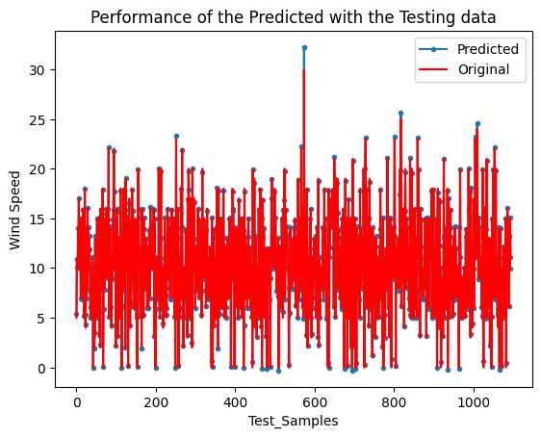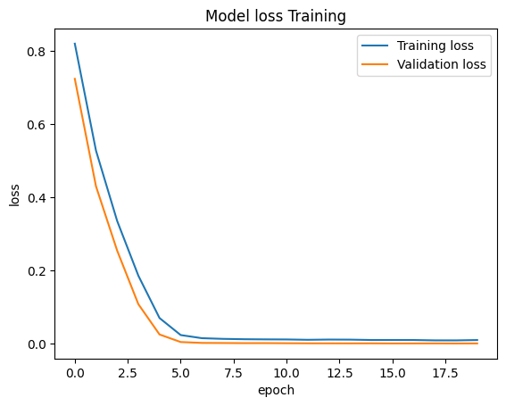**Figure 4.4:** Model Loss Training

**Figure 4.5:** Performance of the Predicted and Testing Data

### **4.3** **Part C: Comparison of the Proposed Model with other models**

To evaluate the proposed LSTM's ability to handle data with long-term dependencies and its overall superiority, we compared it with several other prediction models, including EEMD-BA-RGRU (a variant of RNN) and combinations of LSTM with other models like EEMD-LSTM-LSSVM, WOA-LSTM, SARIMA-LSTM, and BiLSTM (singly) as well as BiLSTM combined with other models like SVR-BiLSTM and CNN-BiLSTM. These models were selected because they were found to be the most accurate and have fewer error metrics based on the papers reviewed. We used MAPE, MAE, and RMSE as error metrics for comparison, as shown in Table 4.

The comparison as shown in Table 4.12 revealed that EEMD-BA-RGRU had higher error metrics than the proposed model, with a reduction in MAE and RMSE to 7.07% and 8.69%, respectively, for the EEMD-BA-RGRU model. Similarly, other models based on the combination of LSTM with other models such as EEMD-LSTM-LSSVM, WOA-LSTM, and SARIMA-LSTM showed less accuracy compared to the proposed model, with reductions in MAPE, MAE, and RMSE ranging from 6.34% to 7.11%, 33.01% to 85.76%, and 46.7% to 111.81%, respectively.

The ANN model used by (Fadare, 2010) had lower prediction accuracy than the proposed model, with a higher MAPE value. Finally, we compared the proposed model with BiLSTM and its combination with other models such as SVR-BiLSTM and CNN-BiLSTM. The proposed model outperformed both BiLSTM and CNN-BiLSTM, with reductions in MAPE and RMSE ranging from 7.64% to 10.84% and 27.64% to 44.69%, respectively, for CNN-BiLSTM and BiLSTM. Only SVR-BiLSTM outperformed the proposed model, with a better MAE and RMSE by 9.09% and 11.51%, respectively, while the proposed model's MAPE showed an improvement in prediction accuracy of 17.97%.

**Table 4.12: Comparison of Proposed Model with other Models**

|  |  |  |  |
| --- | --- | --- | --- |
| Models | MAPE | MAE | RMSE |
| Proposed Model (LSTM) | **0.0416** | **0.1199** | **0.1531** |
| EEMD-BA-RGRU | ----- | 0.1906 | 0.2400 |
| EEMD-LSTM-LSSVM | 0.1127 | 0.9775 | 1.2712 |
| WOA-LSTM | **-----** | 0.64235 | 0.78425 |
| SARIMA-LSTM | 0.105 | 0.45 | 0.62 |
| BiLSTM | 0.15 | **-----** | 0.6 |
| CNN-BiLSTM | 0.118 | 0.3051 | 0.4295 |
| SVR- BiLSTM | 0.2213 | 0.029 | 0.038 |
| ANN | 0.089 | ------ | ------- |

In conclusion, the proposed LSTM wind speed prediction model outperforms all other models in general comparison, demonstrating its effectiveness in wind speed prediction. However, it is important to note that the performance of the model may vary depending on the specific dataset and prediction task at hand. Overall, our findings suggest that wind speed prediction using the proposed LSTM model can be a valuable tool for optimizing wind power generation in the telecommunication industry. By combining this approach with existing solar power generation, we can work towards a more sustainable future for the telecommunications sector.

# CHAPTER FIVE

## CONCLUSION AND RECOMMENDATION

### **5.1 CONCLUSION**

This research works on a wind speed prediction model for telecommunication base stations in Kano, Nigeria. Specifically, the model uses a Long Short-Term Memory (LSTM) algorithm to predict wind speed based on univariate wind speed data. To evaluate the effectiveness of the proposed model, we compared its performance with several other models, including EEMD-BA-RGRU, EEMD-LSTM-LSSVM, WOA-LSTM, SARIMA-LSTM, BiLSTM, CNN-BiLSTM, SVR-BiLSTM, and ANN based on the mean absolute percentage error (MAPE), mean absolute error (MAE), and root mean squared error (RMSE) evaluation metrics. The results showed that the proposed LSTM model outperformed the other models in terms of MAPE, MAE, and RMSE, with values of 0.0416, 0.1199, and 0.1531, respectively.

In addition, the application of this research work proposes the use of a hybrid energy system consisting of existing solar energy generation and efficient wind energy generation to optimize energy usage at BTS locations. Wind energy generation is the output of this research and if used together with solar energy, will provide a more reliable and consistent source of energy for telecommunication base stations. Furthermore, this hybrid energy mode will be resilient to climate change and will be able to generate energy even during adverse weather conditions. In cases where one energy source is not sufficient, the other can compensate for the shortfall, meanwhile, the presence of both will generate surplus energy that can be stored for later use. Ultimately, this hybrid energy system can provide a sustainable and cost-effective solution for powering BTS locations while reducing the carbon footprint and promoting a cleaner environment.

Lastly, the proposed wind power prediction model using LSTM shows promise in accurately predicting wind speed for telecommunication base stations in Kano, Nigeria, and can potentially help to optimize energy usage and promote sustainability in the telecommunications industry. The successful implementation of this model has the potential to create an eco-friendly and cost-effective source of energy and a stable hybrid source of energy for telecommunication-based stations. This will help reduce the carbon footprints in the atmosphere and reduce the over-dependence on fossil fuels in Nigeria. Overall, this research contributes to the development of sustainable energy technologies and has significant implications for the advancement of renewable energy sources in Nigeria and beyond.

### **5.2 RECOMMENDATION**

Although this project focuses solely on using wind speed as input data from a 10-year dataset, future research could explore incorporating additional climate factors that affect wind speed. Utilizing a larger amount of historical data and combining two or more models could further enhance the accuracy of the prediction.

# References

Adaramola, M. S., & Oyewola, O. M. (2011). Evaluating the performance of wind turbines in selected locations in Oyo state, Nigeria. *Renewable Energy*, *36*(12), 3297–3304. <https://doi.org/10.1016/j.renene.2011.04.029>

Adaramola, M. S., Oyewola, O. M., Ohunakin, O. S., & Akinnawonu, O. O. (2014). Performance evaluation of wind turbines for energy generation in Niger Delta, Nigeria. *Sustainable Energy Technologies and Assessments*, *6*, 75–85. <https://doi.org/10.1016/j.seta.2014.01.001>

Adedipe, O., Abolarin, M. S., & Mamman, R. O. (2018). A Review of Onshore and Offshore Wind Energy Potential in Nigeria. *IOP Conference Series: Materials Science and Engineering*, *413*(1). <https://doi.org/10.1088/1757-899X/413/1/012039>

Ajayi, O. O., Fagbenle, ;, & Katende, ; (2011). Wind Profile Characteristics and Econometrics Analysis of Wind Power Generation of a Site in Sokoto State, Nigeria. *ENERGY SCIENCE AND TECHNOLOGY*, *1*(2), 54–66. www.cscanada.net

Ajayi, O. O., Fagbenle, R. O., Katende, J., Aasa, S. A., & Okeniyi, J. O. (2013). Wind profile characteristics and turbine performance analysis in Kano, north-western Nigeria. *International Journal of Energy and Environmental Engineering*, *4*(1), 1–15. <https://doi.org/10.1186/2251-6832-4-27>

Ajayi, O. O., Fagbenle, R. O., Katende, J., Ndambuki, J. M., Omole, D. O., & Badejo, A. A. (2014). Wind energy study and energy cost of wind electricity generation in Nigeria: Past and recent results and a case study for South West Nigeria. *Energies*, *7*(12), 8508–8534. <https://doi.org/10.3390/en7128508>

Ajayi, O. O., Fagbenle, R. O., Katende, J., & Okeniyi, J. O. (2011). Availability of wind energy resource potential for power generation at Jos, Nigeria. *Frontiers in Energy*, *5*(4), 376–385. <https://doi.org/10.1007/s11708-011-0167-5>

Alain Charles. (2015). *Nigeria’s first wind farm almost complete, says power ministry*. <https://africanreview.com/energy-a-power/renewables/nigerian-wind-farm-98-per-cent-complete-confirms-power-ministry>

Amoo, O. M. (2012). Evaluation of the wind energy potential of two south west sites in Nigeria. *Frontiers in Energy*, *6*(3), 237–246. <https://doi.org/10.1007/s11708-012-0201-2>

Antony, E., Sreekanth, N. S., Sunil Kumar, R. K., & Nishanth, T. (2021). Data preprocessing techniques for handling time series data for environmental science studies. *International Journal of Engineering Trends and Technology*, *69*(5), 196–207. <https://doi.org/10.14445/22315381/IJETT-V69I5P227>

Ben, U. C., Akpan, A. E., Mbonu, C. C., & Ufuafuonye, C. H. (2021). Integrated technical analysis of wind speed data for wind energy potential assessment in parts of southern and central Nigeria. *Cleaner Engineering and Technology*, *2*. <https://doi.org/10.1016/j.clet.2021.100049>

Buturache, A.-N., & Stancu, S. (2021). Wind Energy Prediction Using Machine Learning. *Low Carbon Economy*, *12*(01), 1–21. https://doi.org/10.4236/lce.2021.121001

Che, Y., A. Salazar, A., Peng, S., Zheng, J., Chen, Y., & Yuan, L. (2022). A multi-scale model for day-ahead wind speed forecasting: A case study of the Houhoku wind farm, Japan. *Sustainable Energy Technologies and Assessments*, *52*. <https://doi.org/10.1016/j.seta.2022.101995>

Ding, C., Zhou, Y., Ding, Q., & Li, K. (2022). Integrated Carbon-Capture-Based Low-Carbon Economic Dispatch of Power Systems Based on EEMD-LSTM-SVR Wind Power Forecasting. *Energies*, *15*(5), 1613. <https://doi.org/10.3390/en15051613>

Fadare, D. A. (2008). *A Statistical Analysis of Wind Energy Potential in Ibadan, Nigeria, Based on Weibull Distribution Function*. <http://www.akamaiuniversity.us/PJST.htm>

Fadare, D. A. (2010). The application of artificial neural networks to mapping of wind speed profile for energy application in Nigeria. *Applied Energy*, *87*(3), 934–942. <https://doi.org/10.1016/j.apenergy.2009.09.005>

Fagbenle, R. O., Katende, J., Ajayi, O. O., & Okeniyi, J. O. (2011). Assessment of wind energy potential of two sites in North-East, Nigeria. *Renewable Energy*, *36*(4), 1277–1283. <https://doi.org/10.1016/j.renene.2010.10.003>

FRANCAS. (2019). *A guide to using life data analysis, Weilbull Analysis and Failure Forecasting*. https://relyence.com/2019/06/27/guide-weibull-analysis/

Kamgba, F., Edet, C., & Njok, A. (2017). Effects of Some Meteorological Parameters on Wind Energy Potential in Calabar, Nigeria. *Asian Journal of Physical and Chemical Sciences*, *4*(1), 1–7. <https://doi.org/10.9734/ajopacs/2017/37493>

Khan, M., Naeem, M. R., Al-Ammar, E. A., Ko, W., Vettikalladi, H., & Ahmad, I. (2022). Power Forecasting of Regional Wind Farms via Variational Auto-Encoder and Deep Hybrid Transfer Learning. *Electronics (Switzerland)*, *11*(2). <https://doi.org/10.3390/electronics11020206>

Khazaei, S., Ehsan, M., Soleymani, S., & Mohammadnezhad-Shourkaei, H. (2022). A high-accuracy hybrid method for short-term wind power forecasting. *Energy*, *238*. <https://doi.org/10.1016/j.energy.2021.122020>

Kumar, V., Vinothkumar, T., Deepa, S. N., Tamizharasi, S., & Jayalakshmi, N. Y. (2022). *Deep Multilayer Perceptron Wind Speed Estimation Based Artiicial Immune System For Power Generation Prediction*. <https://doi.org/10.21203/rs.3.rs-1355219/v1>

Li, J., Zhang, S., & Yang, Z. (2022). A wind power forecasting method based on optimized decomposition prediction and error correction. *Electric Power Systems Research*, *208*, 107886. <https://doi.org/10.1016/j.epsr.2022.107886>

Maradin, D., Cerović, L., & Mjeda, T. (2017). Economic Effects of Renewable Energy Technologies. *Naše Gospodarstvo/Our Economy*, *63*(2), 49–59. <https://doi.org/10.1515/ngoe-2017-0012>

Meng, A., Chen, S., Ou, Z., Ding, W., Zhou, H., Fan, J., & Yin, H. (2022a). A hybrid deep learning architecture for wind power prediction based on bi-attention mechanism and crisscross optimization. *Energy*, *238*. <https://doi.org/10.1016/j.energy.2021.121795>

NiMet. (n.d.). *Meteorological Services*.

*Normalization  _  Machine Learning*. (n.d.).

Nwokocha, C., Chineke, T. C., Nwofor, O., & Okoro, U. (2009). *Estimation of solar radiation in Southeastern Nigeria Energy diversion initiatives and options for Nigeria View project Renewable energy View project*. <https://www.researchgate.net/publication/288847750>

Odo, F. C., Offiah, S. U., & Ugwuoke, P. E. (n.d.). *Weibull distribution-based model for prediction of wind potential in Enugu, Nigeria*. www.pelagiaresearchlibrary.com

Olaoye, T., Ajilore, T., Akinluwade, K., Omole, F., & Adetunji, A. (2016). Cite This Article: Tunde Olaoye, Titilayo Ajilore, Kunle Akinluwade, Femi Omole, and Adelana Adetunji. *American Journal of Electrical and Electronic Engineering*, *4*(1), 1–8. https://doi.org/10.12691/ajeee-4-1-1

Olatomiwa, L., Mekhilef, S., Huda, A. S. N., & Sanusi, K. (2015). Techno-economic analysis of hybrid PV–diesel–battery and PV–wind–diesel–battery power systems for mobile BTS: The way forward for rural development. *Energy Science and Engineering*, *3*(4), 271–285. <https://doi.org/10.1002/ese3.71>

Olayinka, S. O. (2011). Wind Characteristics and Wind Energy Potential Assessment in Uyo, Nigeria. *Journal of Engineering Aand Applied Sciencs*, *6*(2), 141–146.

Olujobi, O. J., & Olusola-Olujobi, T. (2020). Nigeria: Advancing the Cause of Renewable Energy in Nigeria’s Power Sector through its Legal Framework. *Environmental Policy and Law*, *50*(4–5), 433–444. <https://doi.org/10.3233/EPL-200246>

Oyedepo, S. O., Adaramola, M. S., & Paul, S. S. (2012). *Analysis of wind speed data and wind energy potential in three selected locations in south-east Nigeria*. <http://www.journal-ijeee.com/content/3/1/7>

Owusu, P. A., & Asumadu-Sarkodie, S. (2016). A review of renewable energy sources, sustainability issues and climate change mitigation. In *Cogent Engineering* (Vol. 3, Issue 1). Cogent OA. https://doi.org/10.1080/23311916.2016.1167990

Patel, Y., & Deb, D. (2022). Machine Intelligent Hybrid Methods Based on Kalman Filter and Wavelet Transform for Short-Term Wind Speed Prediction. *Wind*, *2*(1), 37–50. <https://doi.org/10.3390/wind2010003>

Poudel, P., Bae, S. H., & Jang, B. (2018). Comparison of Different Deep Learning Optimizers for Modeling Photovoltaic Power. *J. Chosun Natural Sci*, *11*(4), 204–208. <https://doi.org/10.13160/ricns.2018.11.4.204>

Rahman, M. M., Shakeri, M., Khatun, F., Tiong, S. K., Alkahtani, A. A., Samsudin, N. A., Amin, N., Pasupuleti, J., & Hasan, M. K. (2022). A comprehensive study and performance analysis of deep neural network-based approaches in wind time-series forecasting. *Journal of Reliable Intelligent Environments*. <https://doi.org/10.1007/s40860-021-00166-x>

Rukshan Pramoditha. (2022). *How to Choose the Right Activation Function for Neural Networks Analyzing different types of activation functions with visual representations-Neural Networks and Deep Learning Course: Part 5*. <https://towardsdatascience.com/how-to-choose-the-right-activation-function-for-neural-networks-3941ff0e6f9c>

Statista. (2023). *Share of renewable energy consumption worldwide by technology 2023 | Statista Global share of renewable energy consumption by technology 2017-2023*. [https://www.statista.com/statistics/663599/share-of-renewable-electricity-consumed-by-re100-members-by-technology/1/3Source:https://www.statista.com/statistics/663599/share-of-renewable-electricity-consumed-by-re100-members-by-technology/](https://www.statista.com/statistics/663599/share-of-renewable-electricity-consumed-by-re100-members-by-technology/1/3Source:https:/www.statista.com/statistics/663599/share-of-renewable-electricity-consumed-by-re100-members-by-technology/)

Sun, F., & Jin, T. (2022). A hybrid approach to multi-step, short-term wind speed forecasting using correlated features. *Renewable Energy*, *186*, 742–754. <https://doi.org/10.1016/j.renene.2022.01.041>

T, F. A., O, A. C., B, A. T., O, S. R., B, F. E., A, A. K., & A, O. E. (2017). Evaluation of Wind Energy Potential of Ikeja, Southwest, Nigeria using Two-Parameter Weibull Distribution Function. In *IOSR Journal of Engineering (IOSRJEN) www.iosrjen.org ISSN* (Vol. 07). www.iosrjen.org

Technická univerzita (Košice, S. S. S. of A. C. and I., IEEE Systems, M., IEEE Hungary Section, IEEE Systems, M., & Institute of Electrical and Electronics Engineers. (n.d.). *Informatics 2019 : IEEE 15th International Scientific Conference on Informatics : proceedings : November 20-22, 2019, Poprad, Slovakia.*

UNEP. (2017). *The Adaptation Gap Report 2017 : towards global assessment*. UNEP.

United Natons. (2015). *Transforming our world: the 2030 Agenda for Sustainable Development Preamble*. https://sdgs.un.org/2030agenda

Vidyanandan, K. V. (2018). *Overview of Electric and Hybrid Vehicles*. <https://www.researchgate.net/publication/323497072>

Wang, J., Gao, D., Zhuang, Z., & Wu, J. (2022). An optimized complementary prediction method based on data feature extraction for wind speed forecasting. *Sustainable Energy Technologies and Assessments*, *52*. <https://doi.org/10.1016/j.seta.2022.102068>

Wikipedia. (n.d.). *Kano State - Wikipedia*.

Wu, J., Li, N., Zhao, Y., & Wang, J. (2022). Usage of correlation analysis and hypothesis test in optimizing the gated recurrent unit network for wind speed forecasting. *Energy*, *242*. <https://doi.org/10.1016/j.energy.2021.122960>

Xu, Y., Jia, L., & Yang, W. (2022). Correlation based neuro-fuzzy Wiener type wind power forecasting model by using special separate signals. *Energy Conversion and Management*, *253*. <https://doi.org/10.1016/j.enconman.2021.115173>

Ye, L., Dai, B., Pei, M., Lu, P., Zhao, J., Chen, M., & Wang, B. (2022). Combined Approach for Short-Term Wind Power Forecasting Based on Wave Division and Seq2Seq Model Using Deep Learning. *IEEE Transactions on Industry Applications*, *58*(2), 2586–2596. <https://doi.org/10.1109/TIA.2022.3146224>

Zhang, D., Chen, Z., & Zhou, Y. (2022). Wind Power Interval Prediction Based on Improved Whale Optimization Algorithm and Fast Learning Network. *Journal of Electrical Engineering and Technology*, *17*(3), 1785–1802. <https://doi.org/10.1007/s42835-022-01014-5>

# APPENDICES

**Project Code**

# Import all necessary libraries

import numpy as np

import sklearn

from tensorflow.keras.models import Sequential

from tensorflow.keras.layers import LSTM

from tensorflow.keras.layers import Dense, Dropout

import pandas as pd

from matplotlib import pyplot as plt

from sklearn.preprocessing import StandardScaler

#Read the csv file

df = pd.read_csv('wsp_for_one_feature.csv')

print(df.head()) #7 columns, including the Date.

# Plotting the All Wind speed data

print("Plot Loading... ")

plt.plot(df["date"], df["wsp"])

plt.title("All Samples")

plt.xlabel("Date")

plt.ylabel("Wind Speed")

plt.show()

#Plot Training Data

train_date= df.loc[0:2556, 'date']

train_wsp= df.loc[0:2556,'wsp']

train_date= pd.DataFrame(train_date)

train_wsp= pd.DataFrame(train_wsp)

train_data = train_date.join(train_wsp,how='outer')

plt.plot(train_data["date"], train_data["wsp"])

plt.title("Training Data")

plt.xlabel("Date")

plt.ylabel("Wind Speed")

plt.show()

#Plot Testing Data

test_date= df.loc[2557:3652, 'date']

test_wsp= df.loc[2557:3652,'wsp']

test_date= pd.DataFrame(test_date)

test_wsp= pd.DataFrame(test_wsp)

test_data = test_date.join(test_wsp,how='outer')

plt.plot(test_data["date"], test_data["wsp"])

plt.title("Testing Data")

plt.xlabel("Date")

plt.ylabel("Wind Speed")

plt.show()

#Variables for training

cols = list(df)[1:2]

df_for_training = df[cols].astype(float)

raw = df['wsp'].tolist()

# univariate data preparation

from numpy import array

# split a univariate sequence into samples

def split_sequence(sequence, n_steps):

X = list()

for i in range(len(sequence)):

# find the end of this pattern

end_ix = i + n_steps

# check if we are beyond the sequence

if end_ix > len(sequence)-1:

break

# gather input and output parts of the pattern

seq_x = sequence[i:end_ix]

X.append(seq_x)

return array(X)

# define input sequence

n_steps = 6

# split into samples

X= split_sequence(raw, n_steps)

df = pd.DataFrame(X)

df_for_training = df.astype(float)

print(df_for_training.head())

#Standardize the datasets

scaler = StandardScaler()

scaler = scaler.fit(df_for_training)

df_for_training_scaled = scaler.transform(df_for_training)

#Empty lists to be populated using formatted training data

X = []

Y = []

n_future = 1 # Number of days we want to look into the future based on the past days.

n_past = 14 # Number of past days we want to use to predict the future.

#Reformat input data into a shape: (n_samples x timesteps x n_features)

#In this example, df_for_training_scaled has a shape (3653, 1)

#3653 refers to the number of data points and 1 refers to the columns (single-variable).

for i in range(n_past, len(df_for_training_scaled) - n_future +1):

X.append(df_for_training_scaled[i - n_past:i, 0:df_for_training.shape[1]])

Y.append(df_for_training_scaled[i + n_future - 1:i + n_future, 0])

X, Y = np.array(X), np.array(Y)

print('X shape == {}.'.format(X.shape))

print('Y shape == {}.'.format(Y.shape))

#Splitting data to testing and training sets

from sklearn.model_selection import train_test_split

X_train, X_test,y_train, y_test= train_test_split(X, Y, test_size= 0.3, random_state= 10)

#Stacked LSTM Architecture

model = Sequential()

model.add(LSTM(40, activation='relu', input_shape=(X_train.shape[1], X_train.shape[2]), return_sequences=False))

#model.add(LSTM(100, activation='tanh', return_sequences=False))

# model.add(LSTM(50, activation='relu', return_sequences=False))

model.add(Dropout(0.1))

model.add(Dense(y_train.shape[1]))

# model.compile(optimizer='adam', loss='mse')

model.compile(

optimizer="adam",

loss="mse",

)

model.summary()

# fit the model

history = model.fit(X_train, y_train, epochs=20, batch_size=48, validation_split=0.1, verbose=1)

plt.plot(history.history['loss'], label='Training loss')

plt.plot(history.history['val_loss'], label='Validation loss')

plt.title("Model loss Training")

plt.xlabel("epoch")

plt.ylabel("loss")

plt.legend()

#Evaluate the model on the test data using `evaluate`

print("Evaluate on test data")

results = model.evaluate(X_test, y_test, batch_size=16)

print("test loss, test acc:", results)

#Make prediction

prediction = model.predict(X_test)

#Unstandardize the y_pred and y_test

prediction_copies = np.repeat(prediction, df_for_training.shape[1], axis=-1)

y_pred = scaler.inverse_transform(prediction_copies)[:,0].astype(float)

y_test_copies = np.repeat(y_test, df_for_training.shape[1], axis=-1)

y_true = scaler.inverse_transform(y_test_copies)[:,0]

# #Error margin between the y_pred and y_test

# Error= np.subtract(y_pred, y_test1)

# Error= Error[:,0]

#Performance Metrics

mse = sklearn.metrics.mean_squared_error(y_pred,y_true)

import math

rmse = math.sqrt(mse)

mae= sklearn.metrics.mean_absolute_error(y_pred,y_true)

r2= sklearn.metrics.r2_score(y_pred,y_true)#Coefficient of Determination (R2)

me= sklearn.metrics.max_error(y_true, y_pred)

from sklearn.metrics import mean_absolute_percentage_error

mape= mean_absolute_percentage_error(y_pred, y_true)

r = np.corrcoef(y_pred, y_true)

#Print all Performance metrics

print(f'me= {me}')

print(f'mse= {mse}')

print(f'mae= {mae}')

print(f'rmse= {rmse}')

print(f'r2= {r2}')

print(f'mape= {mape}')

#Plotting the Predicted and Testing data

plt.title('Performance of the Predicted with the Testing data')

plt.plot(y_pred.flatten(),marker= '.', label='Predicted')

plt.plot(y_true.flatten(),'r', label='Original')

plt.xlabel("Test_Samples")

plt.ylabel("Wind Speed")

plt.legend()